
Campus Update

15th November 2024

Dear Parent/Carer,

Our thoughts this week are very much still with those who are feeling the impact of the tragic loss of a much-loved young person. We continue to take strength from the love and support of members of our school community and beyond.

Town and school remembrance events on Sunday and Monday were emotional, but gathering together provided another source of strength and our children and young people did us proud.
A highlight of both events was Pixey Palmer sharing the impact of the Girlguiding movement during the war – fascinating and exceptionally well delivered!

In their classes, many of our children and young people were learning about Remembrance including P2 writing about the significance of poppies and S1’s introduction to metalwork through, the Poppy project; drilling, filing, dip coating, and riveting, completion this week. Some of their beautiful creations are shown below.

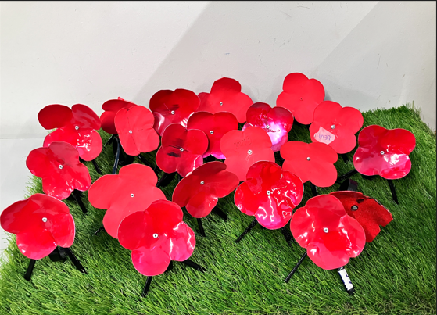

Thank you for your ongoing support at this time. As always, please do not hesitate to get in touch if we can be of support to you or your family.

Kind regards


Susan Oliver
Headteacher

Parents’ Evenings

Primary Parents’ evenings have been rescheduled for Wednesday 4 and Thursday 5 December from 4pm-7pm both evenings.
The booking system opens on Tuesday 26 November at 6.30pm and closes at 11.00pm on Tuesday 3 December, with an invitation sent from the booking system prior to this.

S4-S6 Parents’ evenings – Wednesday 20th November and Thursday 28th November 16.30 – 19.10 Bookings currently open and close on Tuesday 19th.

S1 Parents’ evening is on Thursday 5th December from 16.30 to 19.10. The online booking system will open on Wednesday 27th and full instruction will be sent in advance around how to make
bookings.

S2 Parents’ evening has been rescheduled for Thursday 16th January 2025 from 16.30 to 19.10. The booking system will open on Wednesday 8th January as previous bookings can’t be carried forward. This is the soonest opportunity that we can fit this event into our school calendar. A reminder will be sent when we return to school after the Christmas break. We strongly encourage all parents/carers to make appointments as this forms part of subject choice process for moving into S3.

To log on to book appointments please type the following in your spacebar:
www.parents-booking.co.uk

Learning Without Limits

Tang Soo Do
Huge congratulations to Ben Young S4 who won a full set of medals at the recent Tang Soo Do World Championships in Atlantic City, New Jersey.
Tang Soo Do is a Korean martial art based on Karate, with lineage dating back 2000 years.
If you are interested in finding out more, the Dal Poon Academy offers sessions in JGC on Thursday evenings. It is a family orientated organisation (part of the European Tang Soo Do Federation) and teaches self-defence, discipline, coordination, endurance, self-control as well as much more.

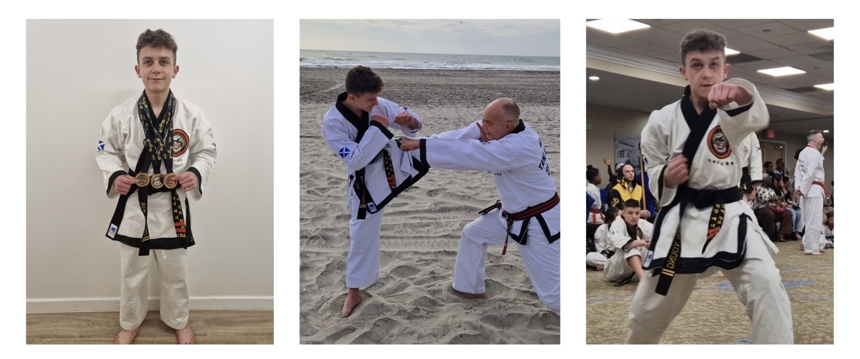
P2 Writing
