
Campus Update

7th March 2025

Dear Parent/Carer,

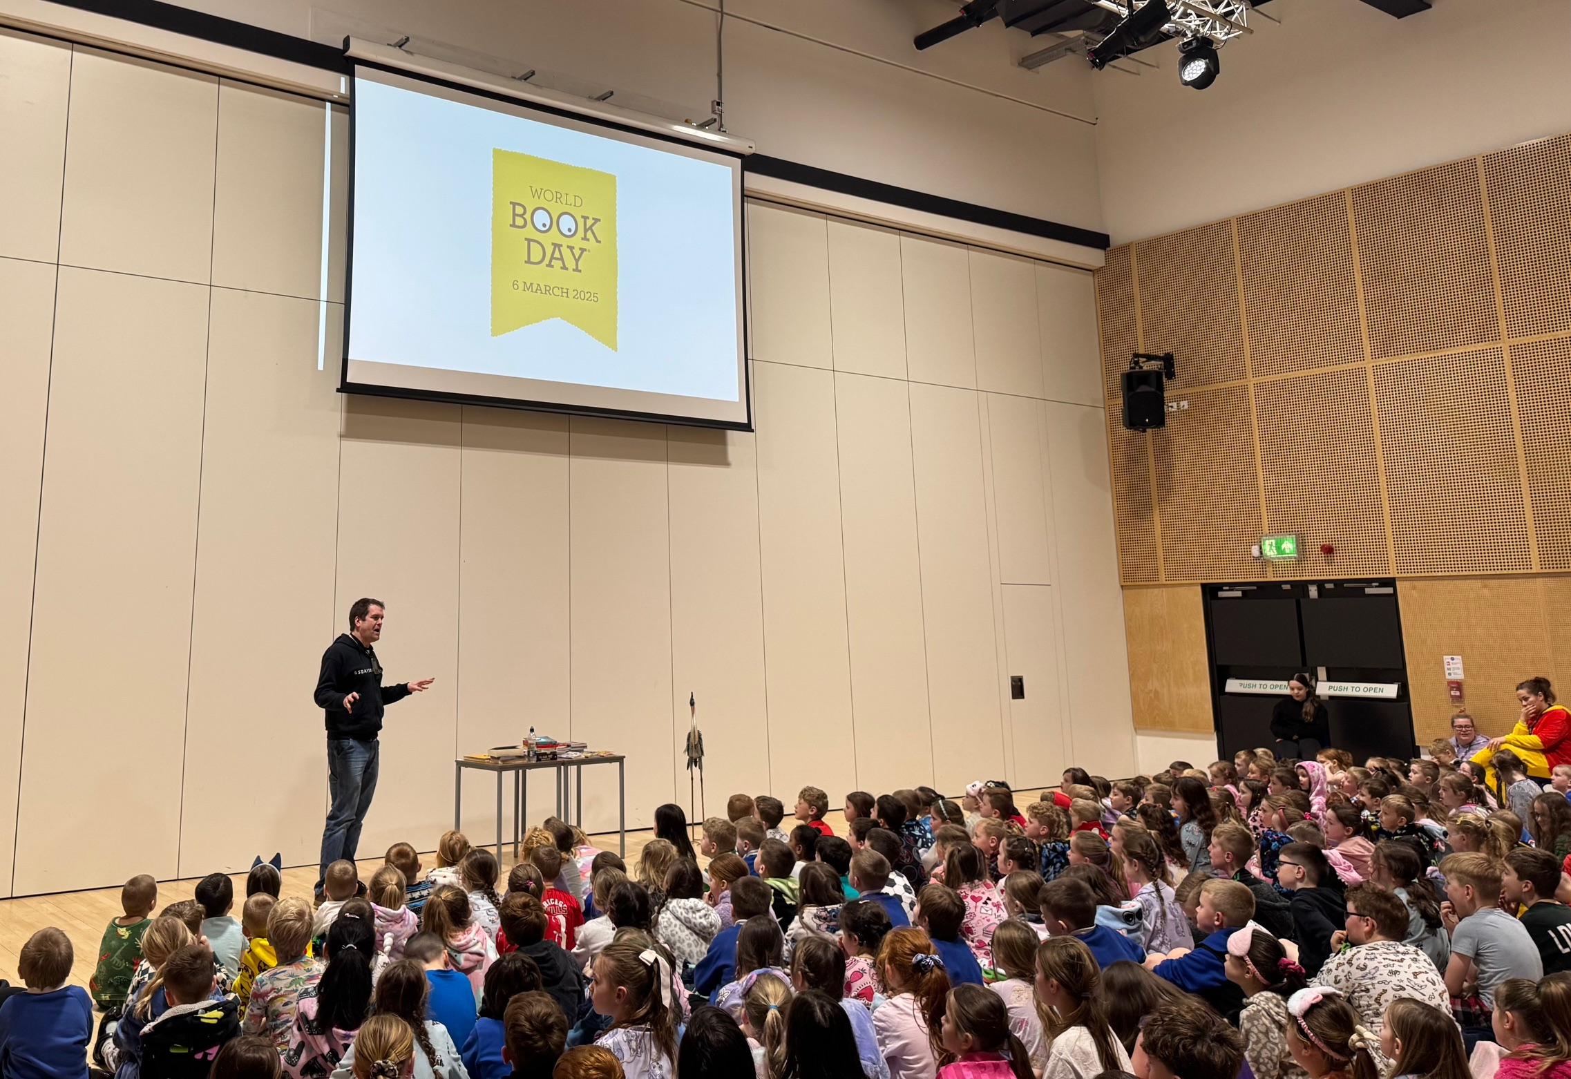
In addition to the excitement of the Jethart Hand Ba’ we had lots of fun yesterday celebrating World Book Day. Huge thanks to Dean from Heron & Willow for leading assemblies where we heard extracts from the special World Book Day £1 books, and learned about Dean’s bookshop.

The children also worked together to devise storylines with a heron as the main character and all children from P1-S2 will have received a World Book Day token either yesterday or today.

Secondary pupils who weren’t involved in Hand Ba’ also had fun taking part in games and activities, including “Guess the Shelfie”!
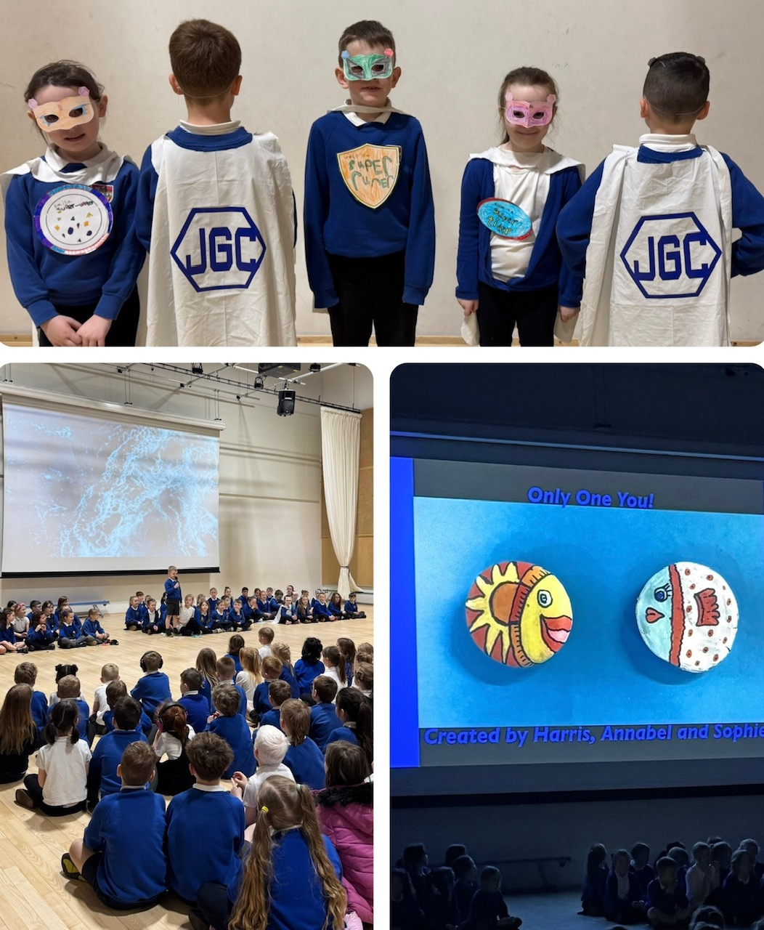
Today our P3 children led a superb class assembly in front of P1-6 and members of their families. They shared with us what makes them all unique and we were treated to fabulous individual and collective performances showcasing a huge range of talents.

Lots of very proud parents, family members and staff and lots of ideas of hobbies and activities for other children to explore. A perfect end to the week!

Wishing you a lovely weekend.



Susan Oliver

Headteacher

Learning Without Limits

STEM
P7 pupils have been making bird boxes as part of their STEM learning and P7 transition. Guided by Miss Mackenzie, the pupils used some of the big machinery and power tools in the Technical Department. They were supported by senior members of JGC Eco Team and Raymond, our BAM Facilities Manager. Some of the bird boxes will be put up around the campus, to improve Biodiversity in the school grounds, which is one of our Eco Schools targets this year. We will donate other boxes to the community. If you would like a bird box for your community space, please contact Sara Lambard at JGC.
Many thanks go to Scottish Borders Climate Action Network who provided funding for the wood as part of their Borders Act for Change initiative this Spring.

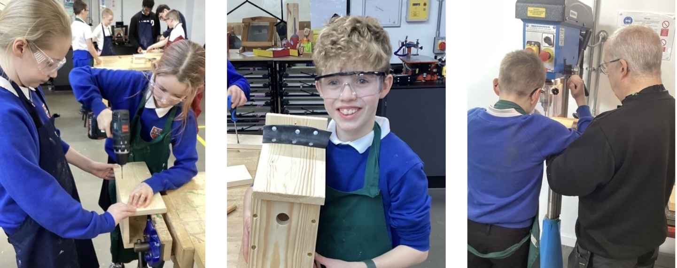

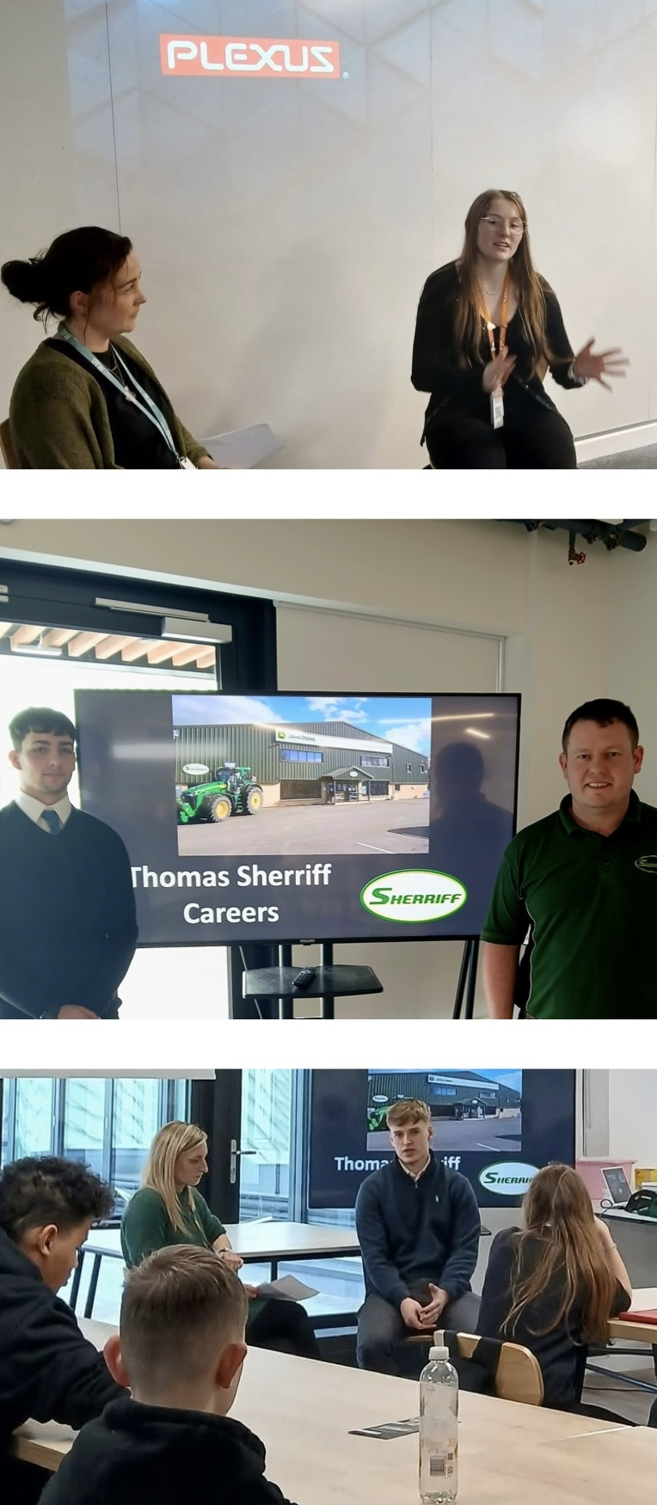
Developing the Young Workforce
DYW and SDS held an Introduction to Apprenticeships session for S2 pupils on Tuesday for Scottish Apprenticeship week. Pupils learned about the different types of apprenticeships available, with local employers Plexus and Thomas Sherriff’s Ltd sharing insight into the value of apprenticeships from a business perspective.

We were delighted that former JGC pupils Euan Munro, Esmee Wragg and Corrie Paterson returned to answer questions about their apprenticeship pathways and that S4 pupil Rory Turnbull, who has secured an apprenticeship with Sherriff’s after leaving school, also shared his journey.

Options Information and Exam Preparation Support
We hope that those of you who were able to attend our secondary information evenings this week found them helpful in terms of explaining the course choice process and how our staff team can work with you and your child to help them find the right pathway through the senior phase and beyond.
If you couldn’t attend, you may find the links below useful. As always, please get in touch if you have any queries or would like to discuss any aspect of the coursing process or support available.

JGC Options Process 2025-26

Raising Attainment Programme: Extra Free Support & Tuition for S4-S6
(including Easter school offer)

Study leave for most young people sitting two or more exams in S4, S5, and S6 will begin on Monday 28th April and end on Friday 30th May. For young people sitting Psychology or Computing Studies first day of study leave will be Thursday 24th April 24th. Students sitting fewer than two exams will be enrolled in our Inspiring Young Minds Programme, which will run throughout April and May. During study leave, young people are welcome to come into school (in uniform) to use study spaces, Wi-Fi, the canteen and receive support from their teachers during scheduled periods.

Parent Partnership Meeting
All parents/cares are welcome to attend our Parent Partnership meeting on Tuesday 12th March at 6.30pm in the campus. This fabulous



