
Campus Update

10th May 2024

Dear Parent/Carer,

It’s been a short week for our children and young people, but it has been lovely to have more opportunities to take learning outdoors and make the most of the better weather!

Our primary 2 children had hoped to say a special farewell to Mrs Gomez today as she left to start her maternity leave . . . however baby Gomez had other plans! I am delighted to share with you that Nina arrived safe and sound earlier today. Mum and baby are both well and a photo of P2 looking “pretty in pink” will be sent to Mrs Gomez ♡
Miss Makin will be covering Mrs Gomez’s maternity leave from Monday.

Wishing you a lovely weekend.
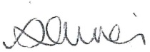

Susan Oliver
Headteacher

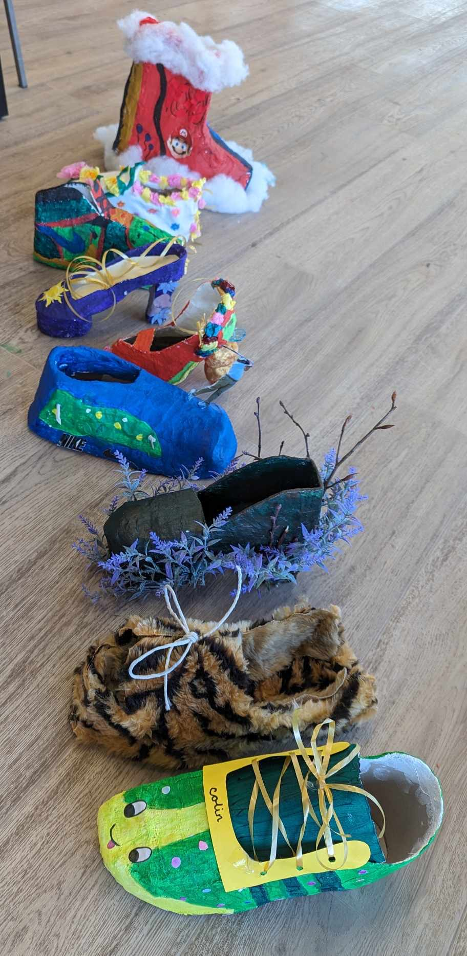
Learning Without Limits

Art at Ancrum
There were a wide range of exhibits around Ancrum last weekend, including these fabulous vases and shoes created by our young people.

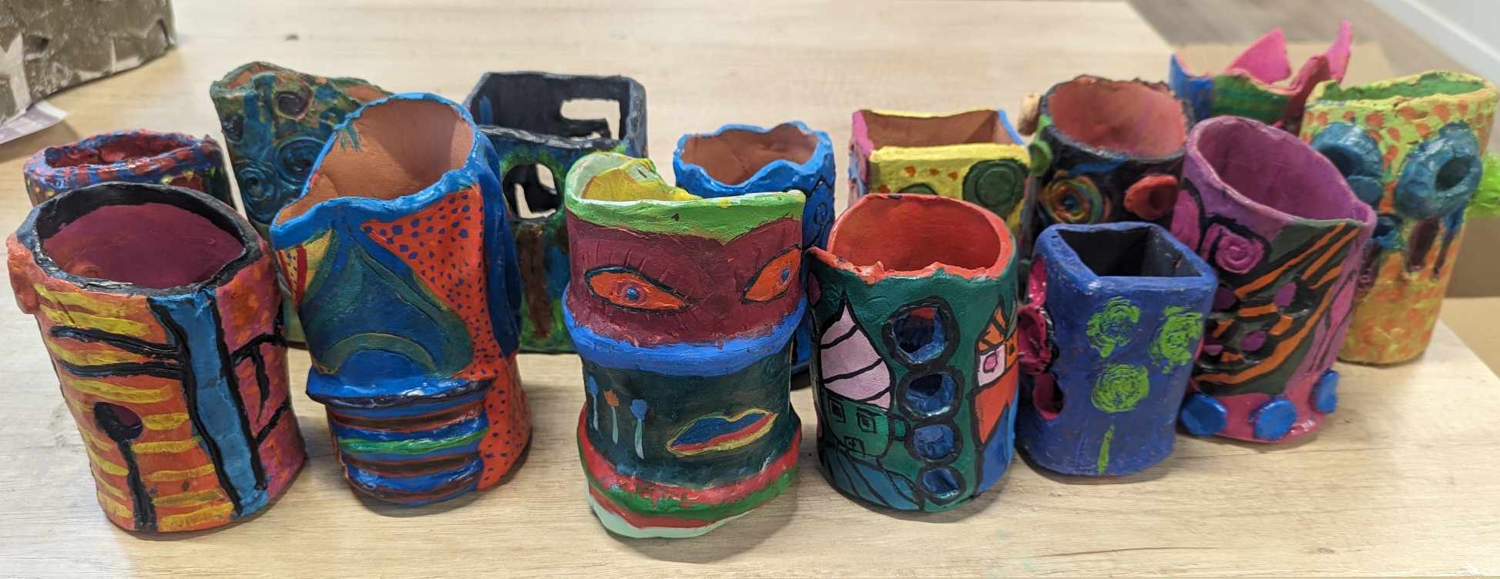

JGC on tour

We are always grateful to our staff for organising opportunities for our children and young people to learn off site and to explore our surrounding area.
Last Friday and today our ELC children had a fantastic time visiting Jedburgh Castle Jail and our Bronze Duke of Edinburgh participants have now all successfully completed their practice expedition, walking to Morebattle with an overnight camping stop.
Great fun for all involved and campus values displayed by the bucket load!
