
Campus Update

31st May 2024

Dear Parent/Carer,

We had a fantastic time last night, celebrating our 2024 leavers and partying at our Senior Prom. Great speeches from our Head Team, brilliant musical performances from Thomas Brown in S2, Caitlin Robb in S3 and our staff band along with touching tributes to each of the leavers, delivered by Mr Hawkshaw and Mrs Wilcock. As always, our PE team did a sterling job of leading the dancing . . . although I did need a lie down after the 10+ minute Orcadian Strip the Willow. If you haven’t done this dance to The Killers “Mr Brightside” on repeat, I can highly recommend it!
It is always an emotional occasion as we say farewell, but we are incredibly proud of the achievements of all of the young people and know that they will be great ambassadors for our school and community. We wish them well in their future adventures.

Today twenty-six S3 pupils successfully completed their Bronze Duke of Edinburgh Qualifying Expedition, hiking from the JGC to Sprouston, with an overnight stay camping beside the river at Roxburgh. A fantastic achievement by all involved.

Next week brings the start of the new secondary timetable, primary transition days and SBC Inspire Learning events for P6 and S2. June is always a busy time, but we are very much looking forward to lots of fun end of term activities.

Have a lovely weekend.
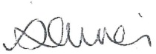

Susan Oliver
Headteacher

Learning Without Limits

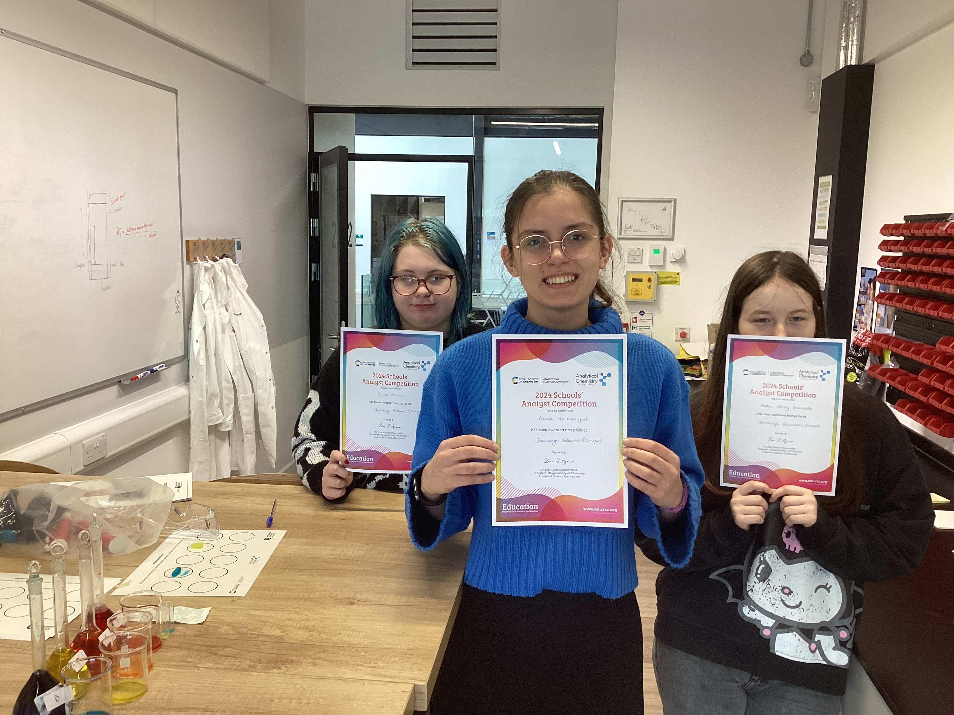
2024 Schools’ Analyst Competition

Congratulations to Ariana, Blythe and Sophie who completed this year's Schools’ Analyst Competition run by Northumbria University, on behalf of the Royal Society of Chemistry. They came into school in their own time to do titrations, thin layer chromatography, gas analysis and some fiendish calculations. The experience will stand them in good stead for UCAS applications and further chemistry studies.

Learning for Sustainability
Some of our primary children were busy this week, harvesting broad beans in the polytunnel, before cooking them in Home Economics and eating them.
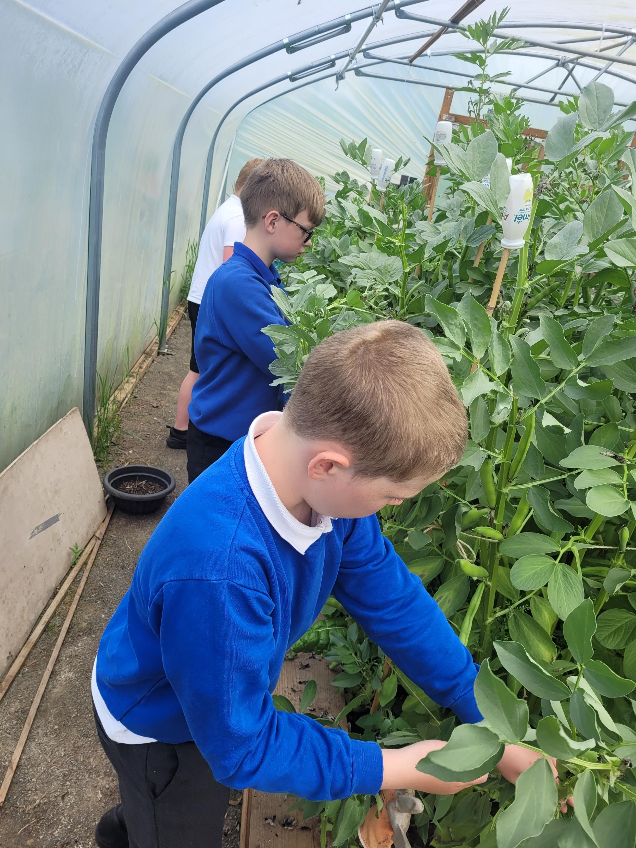
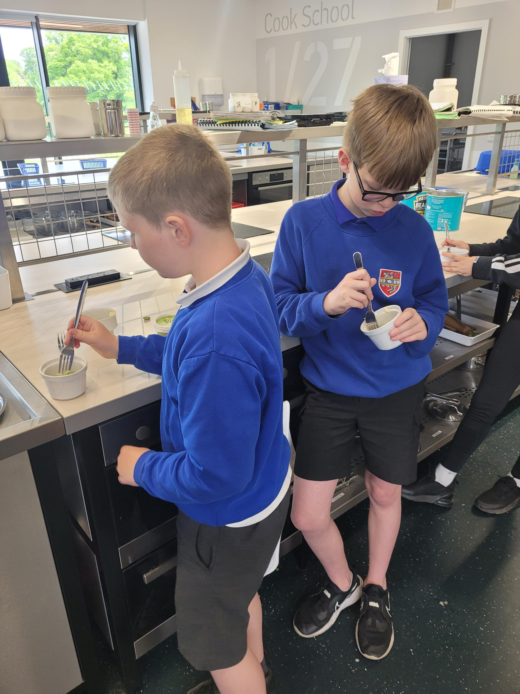

Change of Timetable
Reminder that new S5/6 will receive their timetables during an assembly first thing on Monday 3rd June.

Summer Concert
Tickets are selling fast for our concert. Get yours while you still can!
