
Campus Update

6th September 2024

Dear Parent/Carer,

This week ended on a sad note when we discovered the mindless vandalism of our polytunnel and contents. Many hours of work from children, young people, staff and community volunteers have gone into establishing and maintaining this wonderful, learning space. However, all involved are very determined that we will work together to rectify as much of the damage as possible.

On a happier note, our senior head team carried out their first duty perfectly, leading our P7s through the process of electing our junior head team. Our junior office bearers for 2024-25 are:
Thea Crozier, Harry Henderson, Harry Nicol, Erin Perez, Ben Raeburn and McRae Black Robertson. (Photo to follow next week!)

Wishing you a lovely weekend.


Susan Oliver
Headteacher

Learning Without Limits
United Nation Convention on the Rights of the Child (UNCRC)

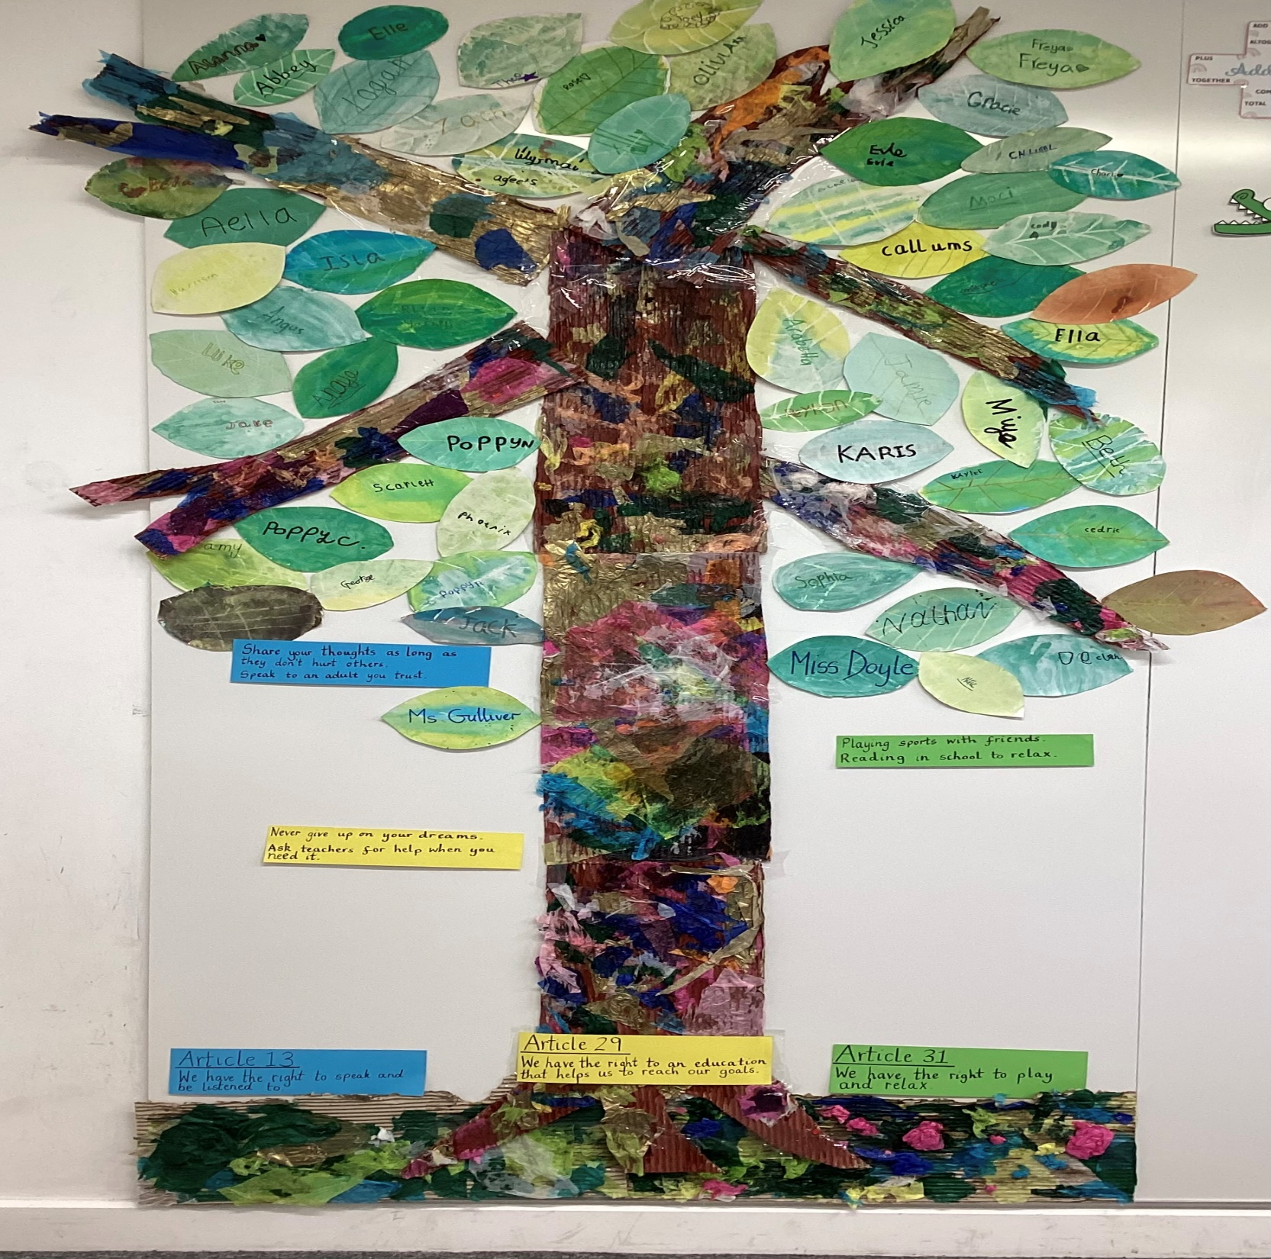
Our children have been learning about the UNCRC and the rights of children. In assembly over the coming weeks P3-5 will be sharing how they created class charters based around the UNCRC articles and children’s rights. Last week P5 shared their charter, presented as a tree which grows and blooms like their minds. The children explained which rights they had focused on and how these could be demonstrated in the classroom.

Over the next few weeks P4 and P3 will also share theirs. Ask your child about their class charter and find out more!
Tour of Britain
Some of our young people made artwork to welcome the cyclists and many enjoyed watching the peloton and entourage as they flew through the town.

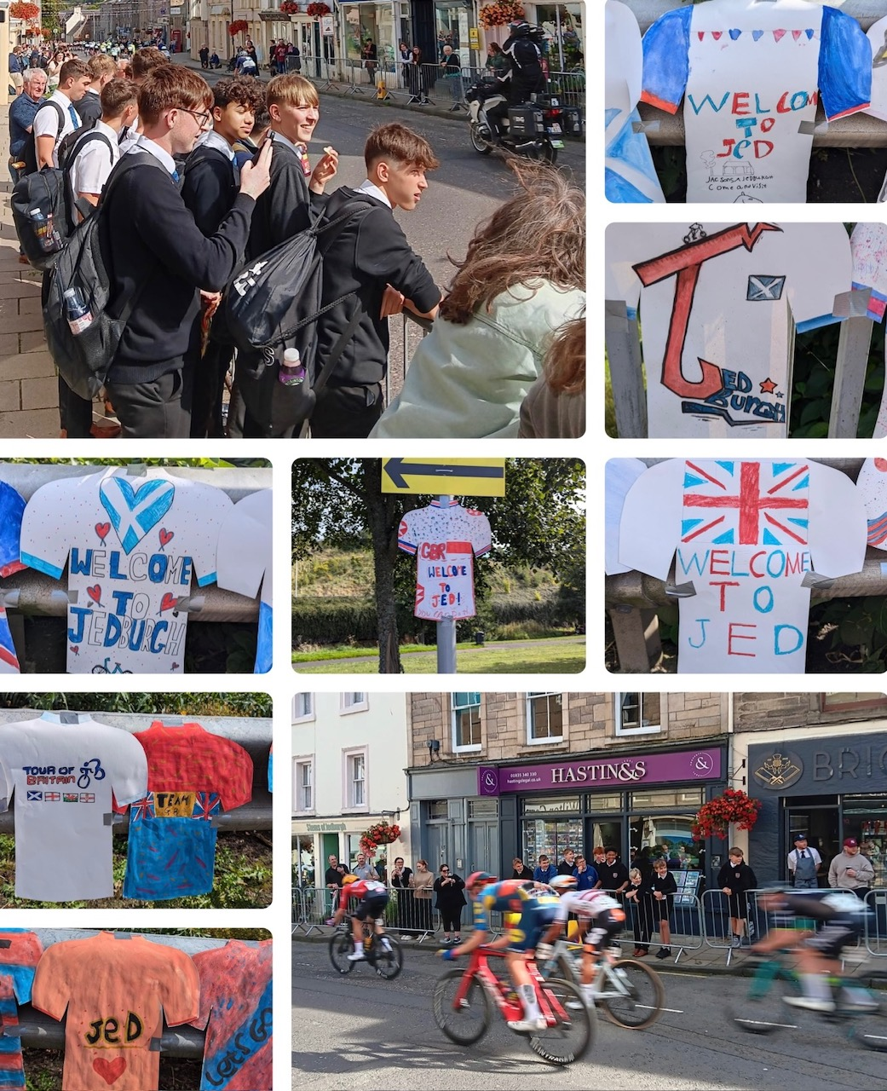

Meet the Teacher: Wednesday 11th September 4.30pm – 5.30pm.

Reminder that P1-S1 parents/carers are invited to visit on Wednesday to see where your children learn and meet their teachers. This is an informal drop-in event so no bookings are required.
Parents of P1 children are also invited to attend an additional session to hear about the teaching of phonics and how you can help your child(ren) at home with this. This session will take place in the P1 learning space at 4pm on Wednesday 11th.
Members of our Parent Partnership group will also be present and happy to share with you how they support the school, while tempting you with a bake sale of sweet treats!

Family Opportunities

