
Campus Update

24th January 2025

Dear Parent/Carer,

I hope this finds you safe and warm, escaping the worst of Storm Éowyn.

Senior Phase prelims have gone smoothly, with the exception of today’s which have been delayed for obvious reasons. Our young people have worked hard and hopefully all will feel the benefit of this experience in terms of identifying next steps in their learning.

On Wednesday evening, several of our young people were involved in our first ever heat of the Rotary’s Young Musician of the Year competition. Thank you to the Rotary Club of Jedburgh for inviting us to participate. Outstanding performances by all involved and our best wishes go to
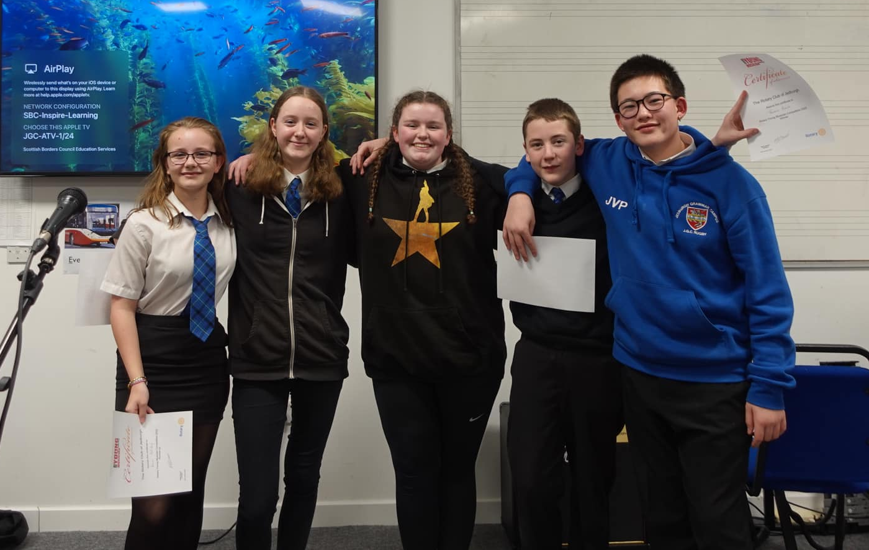
Jacob and Poppy for the next round.

Another highlight of this week was receiving the certificate recognising our achievement of Bronze Rights Respecting School status. (I would have included a photograph, but it is sitting on my desk in school!) We are already well on our way to achieving the Silver Award and are excited to be working with our children, young people and staff to achieve this.

We look forward to seeing everyone back in school on Monday but, in the meantime, stay safe.



Susan Oliver
Headteacher

SBC School Holiday Survey
Reminder that you can still have your say on proposed school holiday dates and in service days for 2026/27 to 2028/29. You can find further information and take part here: https://ow.ly/IuJI50UBIkG

Learning Without Limits

Famous Scots
Children in P3 and P4 have been learning about Charles Rennie Mackintosh and created their own beautiful, Rennie Mackintosh inspired roses by using the visual elements of line, tone, shape and colour.
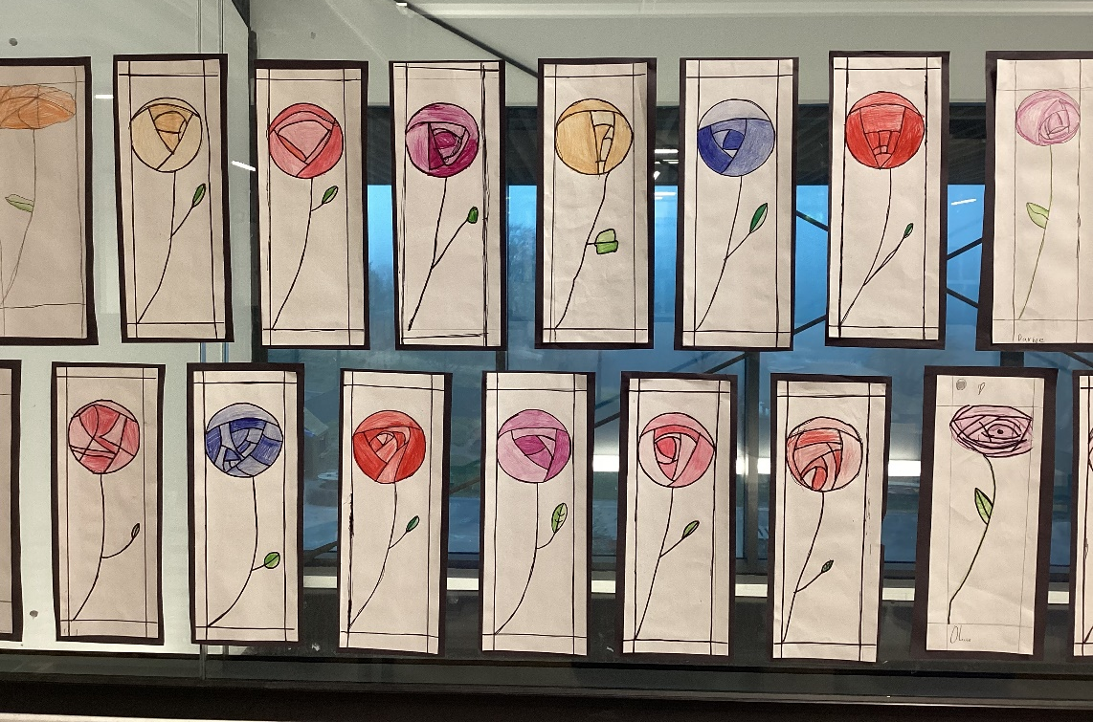

Wellbeing
Primary 7 had a very informative visit from PC Tait-Logan this week, as part of their Health & Wellbeing topic on substance use and misuse.
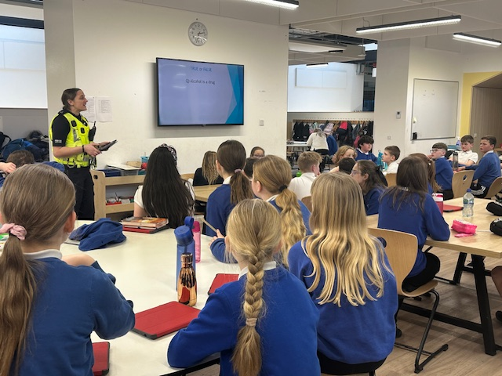

Life Beyond the Classroom
Last term S5 and S6 pupils engaged in workshops with professional financial advisors and educators to get ready for life beyond school and learn all about how to manage their own finances. S5 worked with Denise Murrow and Pauline Smith from Murrow Wealth Management, and enjoyed learning about payslips, pensions, savings, budgeting and much more.

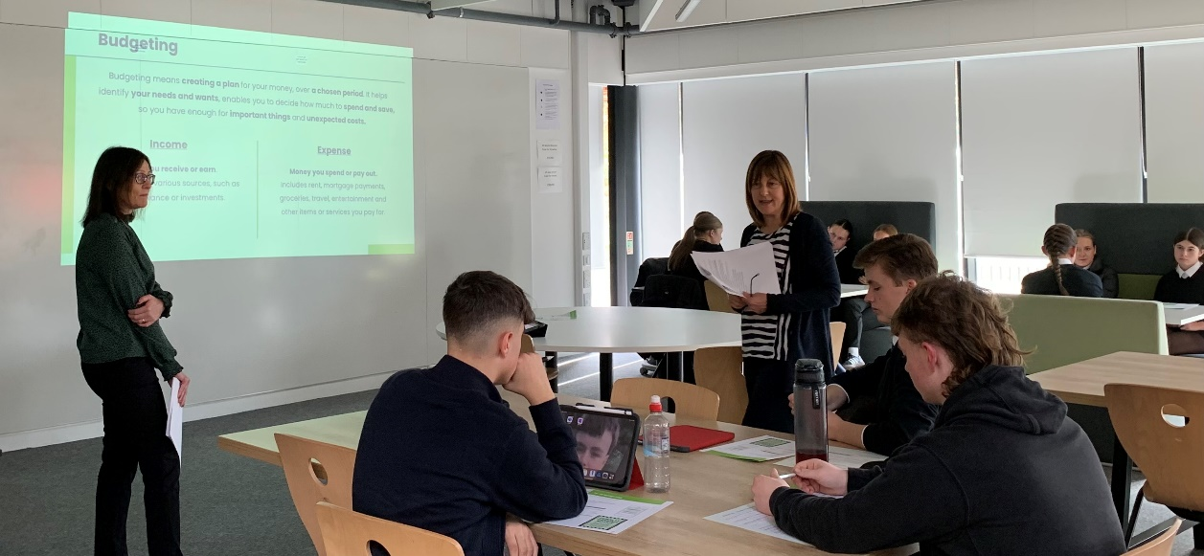

Meanwhile, S6 worked with Leonie Griffin and Catriona Scott of Leaver’s Money Skills. They learned about student bank accounts and different banking apps such as Monza and Starling, exploring how these can be used to help budget, save and handle day to day spending.

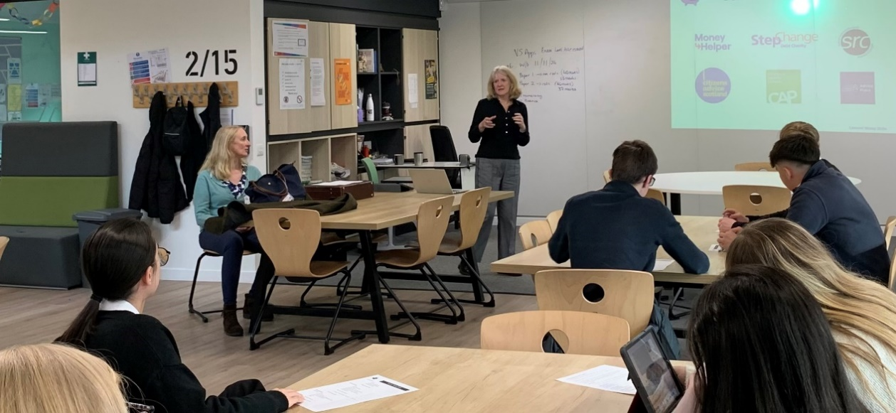

These workshops have become a regular feature of our Senior PSE curriculum and help our pupils to engage meaningfully with the reality of financial independence in the modern world. They include advice on avoiding and paying off debt, breaking unhealthy spending habits, and making your money work for you. Positive feedback from the pupils showed that they feel more confident about making their way in the world beyond school after these workshops. We are very grateful to both Murrow Wealth Management and Leaver’s Money Skills, for their continued support.

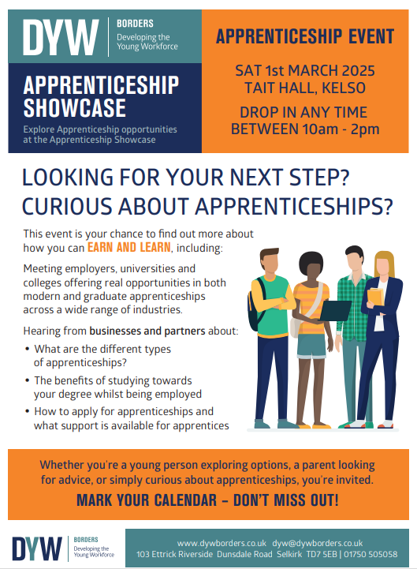
Developing the Young Workforce
DYW are pleased to be holding their first ever Apprenticeship event in the Borders. Taking place on Saturday 1st March, at the Tait Hall in Kelso, it is a great opportunity for pupils, families and employers to go along and find out about modern and graduate apprenticeships and the supports available.

They have businesses, universities and colleges attending who will provide information and guidance on the types of apprenticeships they offer, and the range of industries covered.


Rotary Young Artist Competition 2025
Reminder that this competition is open to children and young people from P4 – S6.


