
Campus Update

27th September 2024

Dear Parent/Carer,

On Tuesday, JGC and our town had a very successful evening at SBC’s Greener Gateway 2024 Awards celebrations.
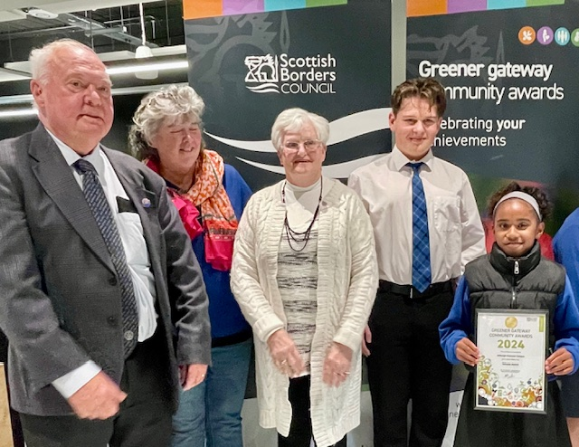
In addition to receiving a Gold Award, in the newly introduced schools category, we were one of two schools awarded overall “Best Projects”, for our Growing Together, intergenerational gardening project. We were delighted that a few of our young people and volunteers were able to collect the awards and receive the recognition in person. A wonderful example of what can happen when staff, pupils and community members work together.

Congratulations and thanks to all involved, in particular Ms Lambard, who oversees the project, and Ryan McDonald, Joshua Bowsher-Gibbs and Miss Smith for their work in producing and submitting the video entry for the awards. I’m sure the group will have lots of ideas of how to spend the £250 voucher received for resources or materials to support the project.

It was great to also see Jedburgh receive a Silver Award in the town category, recognising the civic pride, volunteering efforts and skills that help keep our town looking so well!

In recognition of Climate Week Scotland 2024, you’ll see some other recent examples of learning for sustainability below and we look forward to continuing to explore and develop opportunities which benefit our children, young people and community.

Kind regards,


Susan Oliver
Headteacher

Learning Without Limits

Harvest
Mrs Matthews and Mrs Oliver recently had the pleasure of welcoming the interim Jedburgh Old & Trinity minister, Rev Sarah Cook to JGC. She will be working with us and within the community for the next 15 months. On Friday 11th October she will be helping Mrs Matthews lead the P1-7 Harvest Assembly. During this event children will be able to donate items to our local food bank. After assembly, senior pupils and Rev Sarah will work with the food bank team to ensure these are distributed to local families who would benefit.
Climate Week Scotland 2024: Learning for Sustainability@JGC

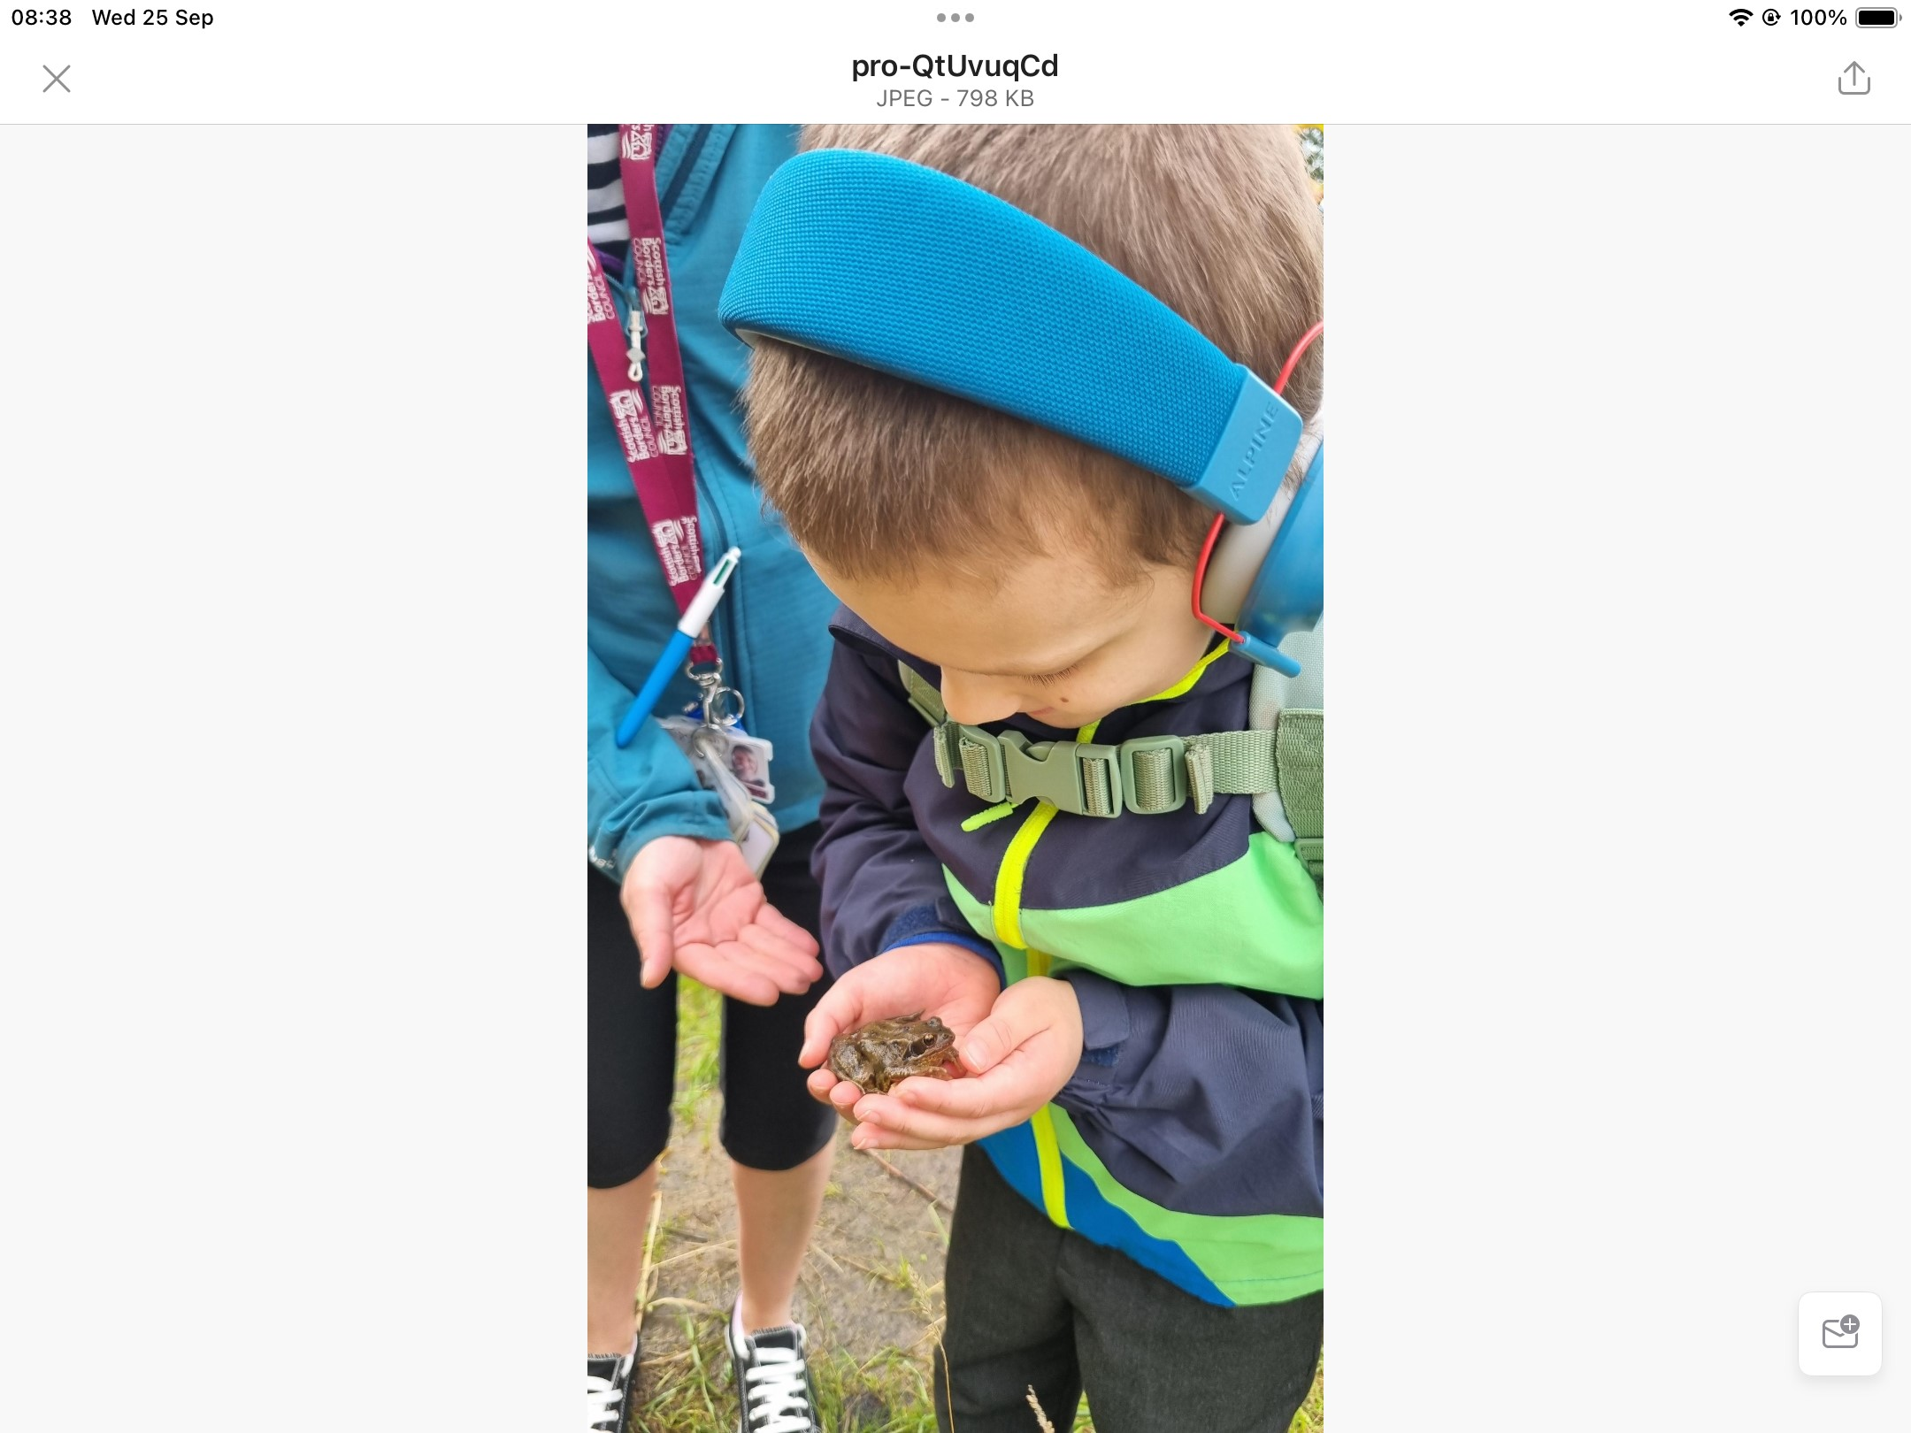
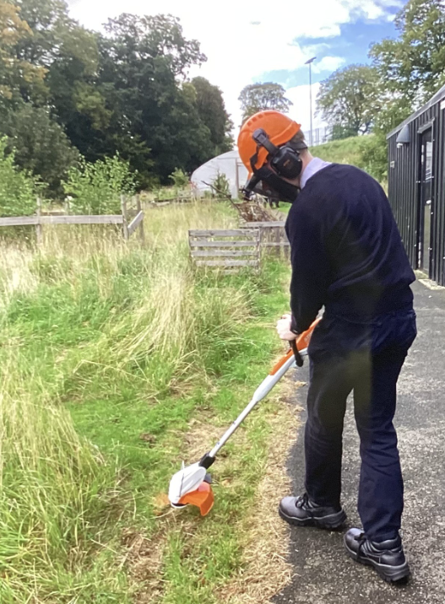
We are currently recording all wildlife that visits us at the campus. Here is Josh, bravely holding a frog we found in the Rose Hub garden! Once our Eco Team receive their bat detector they will be arranging a “Bat Walk”.
One of the best things about the campus setting is the range of outdoor learning opportunities it supports. Here is James in S4, receiving training in use of the strimmer, as part of his Silver Duke of Edinburgh volunteering element.
During study leave before the summer, only primary children were attending Eco Club. They wanted to do something hands on, so planted fruit trees in their playground, made bee hotels with Millfield Care Home and did some growing. Ms Lambard asked them all what they wanted to grow and someone said sweetcorn. They sowed normal corn, baby corn and painted corn which all germinated really well. They took some plants home and planted the rest in the school garden. To Ms Lambard’s surprise, it did really well and on Wednesday it was time to harvest and cook it. It was delicious! The painted corn will be dried to make popping corn with.
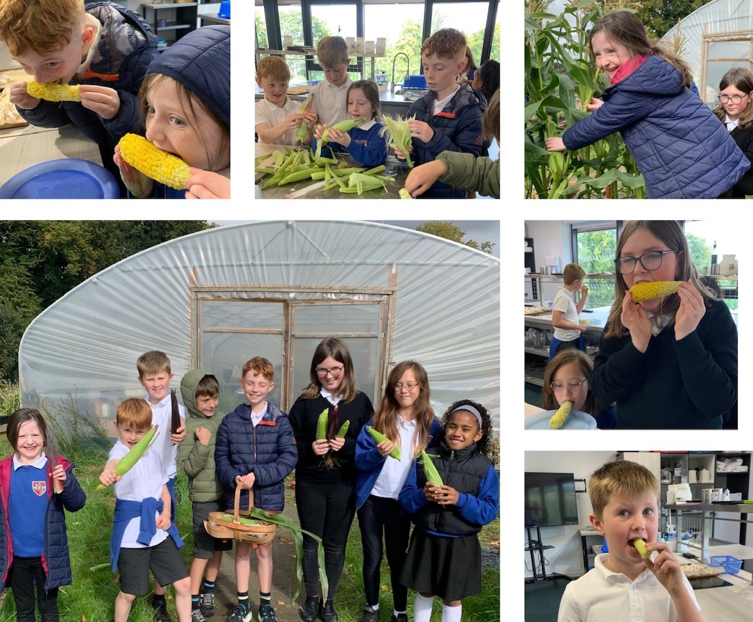

Family Learning - Jed Hearts Here
We are grateful to the Jed Hearts Here team for their ongoing support to JGC, in terms of supplying and maintaining a defibrillator on-site and supporting us with potentially life-saving training.
They are running another community ‘Come and Try’ day at the Fire Station on Sunday 6th October from 11am – 2pm, where all age groups are welcome to learn about CPR and how to use a defibrillator should you ever need it.

JGC Parent Partnership Fundraising Update
We’ve got some exciting news to share with you:


Parentkind – a charity that supports school PTAs - have teamed up with Asda, who is making millions of pounds available to donate to primary schools across the UK through their ‘Cashpot for Schools’ initiative. To support our school, all you have to do is opt-in through the Asda Rewards app, shop and scan in store or shop online at Asda.com.

Between 2 September and 30 November 2024 – every time you shop with Asda using your Asda Rewards app, Asda will donate 0.5% of the value of your shop to your chosen Primary school. Also, every time somebody opts-in to support our Primary school, Asda will give an additional £1 to the school Cashpot. Plus, it doesn’t stop there – Asda are also giving £50 to every school to get them started

It’s easy to join:
1. Download the Asda Rewards app, register and opt-in to Cashpot for Schools (make sure you have the latest version of the app installed)
2. Choose our Primary School – either searching by name or postcode (Jedburgh Grammar Campus or Ancrum Primary School)
3. Shop instore across Asda and George, or online at Asda.com and start filling your Cashpot as you shop
Asda does the rest, all money raised will be donated to schools to spend on the things they need the most.
Remember, anyone can sign up – so start spreading the news and raising funds for our school.

JGC family and friends have already raised over £200!

This initiative is on top of the existing Asda Rewards benefits you get as a shopper – so you won’t lose out on any of your own earnings or Cashpot, so everyone is a winner!
For more details, visit asda.com/cashpotforschools



