
Campus Update

24th May 2024

Dear Parent/Carer,

The end of the SQA exams is finally in sight with only Art & Design remaining next week. We are very proud of how our seniors have approached and handled the exams and we can’t wait to celebrate with them all at our JGC Prom next Thursday evening.
Good luck to our staff who are displaying our campus values this weekend, participating in the Edinburgh Marathon Festival and raising money for a range of very worthwhile causes: Miss Flynn, Mr Johnston, Miss Mackay, Miss Makin, Mr Murray, Mrs Renwick and our Active Schools Coordinator Lauren Grant.


Susan Oliver
Headteacher

Wellbeing
We are aware that there have been a number of cases locally of whooping cough and the East Region Health Protection Team who cover NHS Borders have confirmed that this is in line with the current national picture.
Children or staff with whooping cough must stay off school until they have completed 48 hours of antibiotics, after this they are no longer infectious.
For more information go to Whooping cough | NHS inform

Learning Without Limits

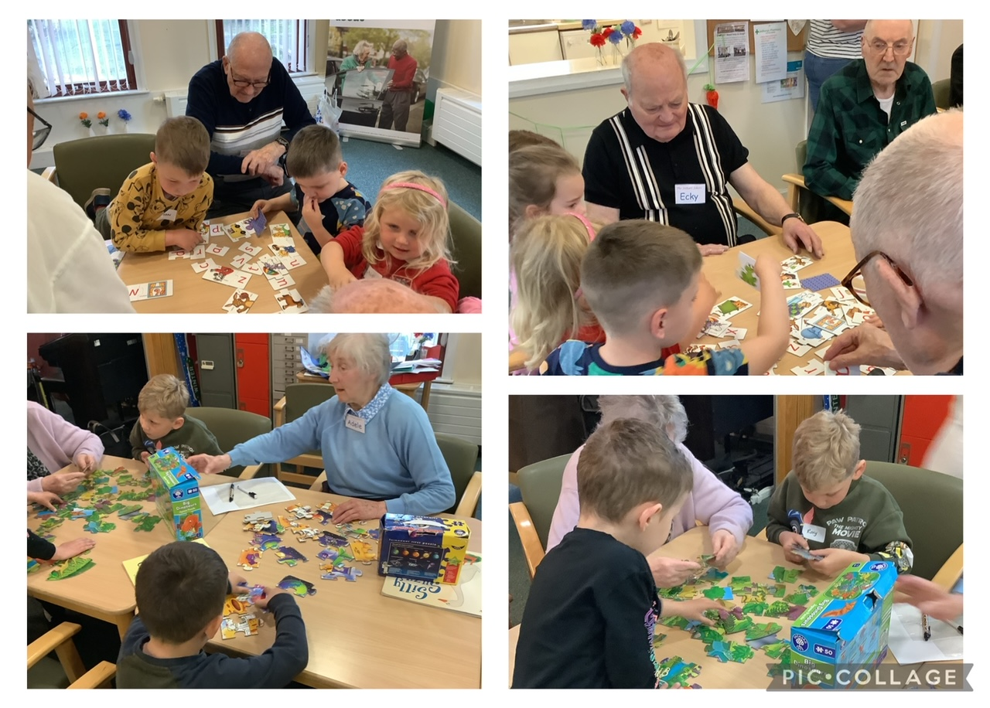
Community Visit
This week it was the turn of some of our nursery children to visit Millfield House. The children took some puzzles and games down to do with the residents and all involved thoroughly enjoyed the time spent together.

Countryside Day
As always, Countryside Day was a highlight of the P5 year. Our children and staff had a fantastic day on Tuesday at Springwood Park. Ancrum pupils joined the JGC P5s as part of their transition.



S2 Residential
Despite what felt like monsoon season, our S2 have displayed campus values by the bucketload during their residential at Whithaugh Park, Newcastleton. They have thrown themselves into all the activities and supported and encouraged each other.

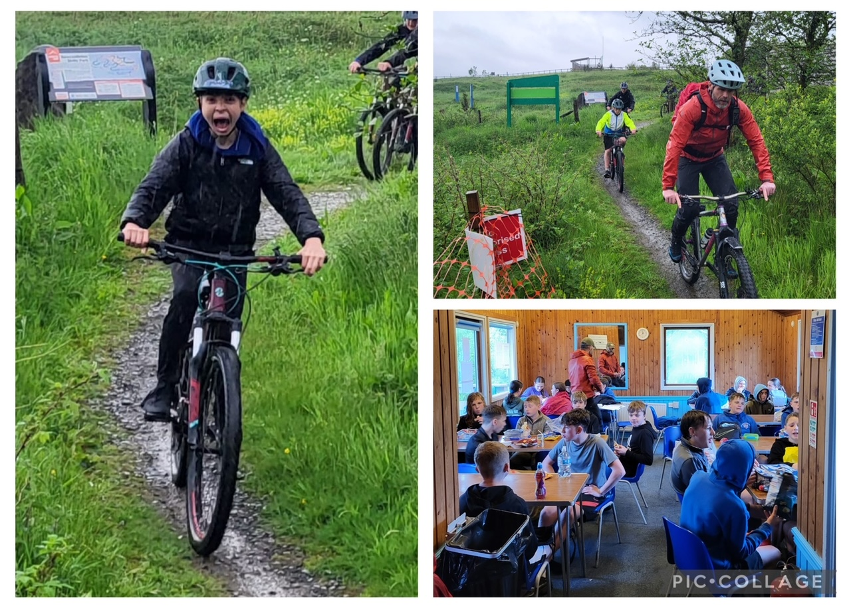

Essential Information for School Leavers
All young people who are due to leave JGC should attend school on Wednesday 29th of May 2.05-3.45. At this time pastoral staff will support them in completing their leavers form.

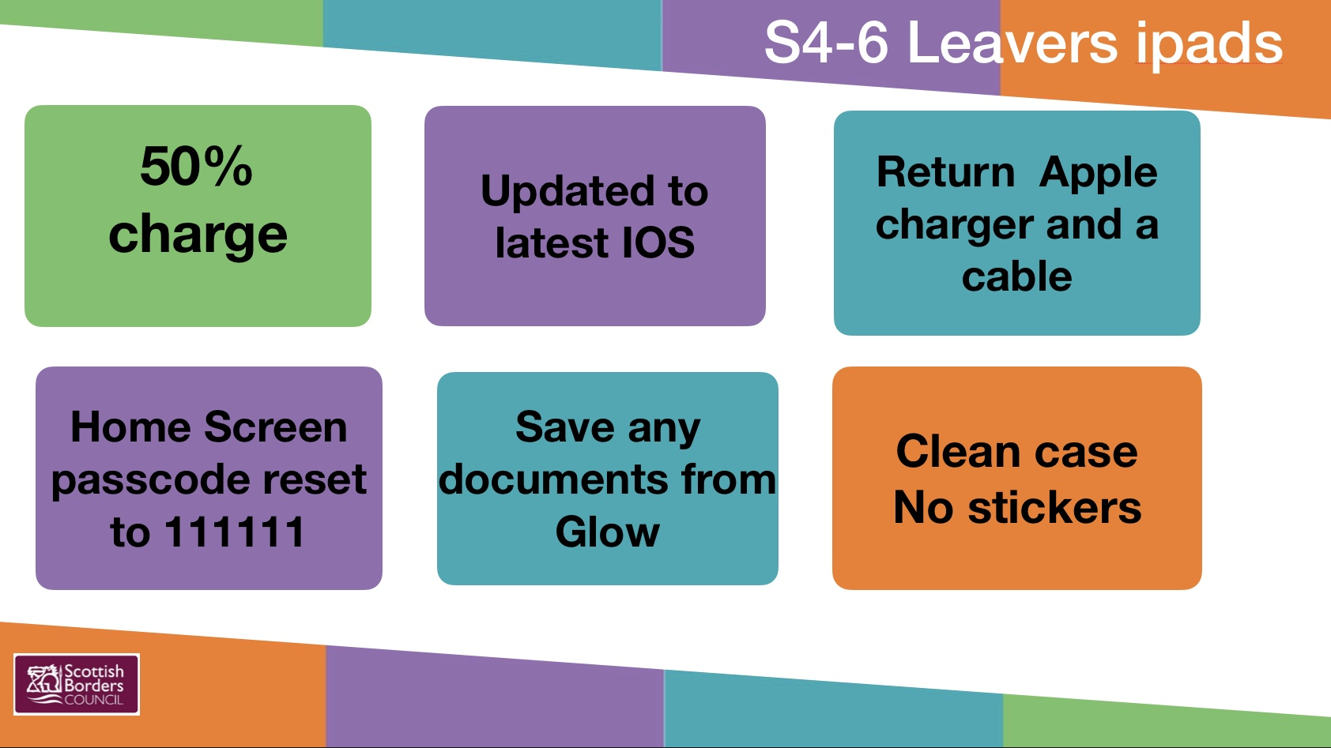
Resources including the iPad, clean case and iPad charger (two piece charger/not an iPhone charger) and cable should also be returned at this time.

Our partners from Skills Development Scotland will also be present with support and guidance to anyone who would like to take up their offer.

See image for details of how to prepare the iPad for return.

Change of Timetable
Current S1-3 pupils will receive their new timetables next week, ready to start on Monday 3rd June. Current S4-5 will receive theirs during an assembly first thing on Monday 3rd.




