
Campus Update

7th June 2024

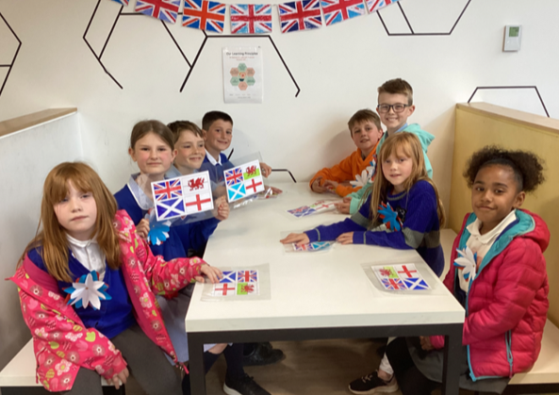
Dear Parent/Carer,

Another busy week here for our learners and staff!
Secondary pupils are settling in well to their new timetables and we enjoyed welcoming children who will be joining P6 and S1 in August from Ancrum, Denholm and St Mary’s primary schools. Our transition days were a great success, with the children having lots of fun exploring the campus and meeting new friends. Here are some P5s (new P6) enjoying the D-Day lunch yesterday.

As you are aware, Alison Monteith will be enjoying a very well-deserved retirement from August and I am delighted to be able to share with you that we have found a very experienced replacement to join our senior leadership team. Mrs Michelle Matthews is well known to many members of our school community, as a previous Cheviot colleague in her role as headteacher of Broomlands Primary, in her capacity as South-East Scotland Improvement Collaborative Associate and the key role she played as Quality Improvement Officer supporter to JGC during the move and pandemic.
We are still trying to get our heads round not having Alison here, but we have no doubt that Michelle will fit in well with our JGC and Ancrum team and support our ongoing improvement journey. Michelle is over the moon to be joining us and very much looking forward to getting to know everyone.
We were delighted to welcome former pupil Miss Mhari Shaw to our Social Subjects teacher team this week and we are also looking forward to our new Principal Teacher of Complex Needs, Rachel Gribbin, leading our Rose Hub Enhanced Provision from August. Rachel spent today in JGC and can’t wait to get started.

Next week we look forward to welcoming parents, carers and family members to our Summer Concert on Tuesday and Campus Sports Wednesday and Friday (details below). Let’s hope for sunshine!

Wishing you a lovely weekend.
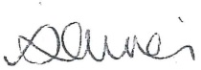

Susan Oliver
Headteacher

Learning Without Limits

JGC Senior Head Team
Applications are being welcomed from young people in our new S6 to be a member of the Senior Head Team for session 2024-25. Those interested should complete the following application https://forms.office.com/e/3uVShLUpYd by 3.45pm on Monday 10th June. A summary of the main points from their applications will be shared with their S6 peers and campus staff, before votes are cast. We hope to share the outcome of this election next week. The new senior office bearers will then lead the election process in August for a new P7 Junior Head Team.
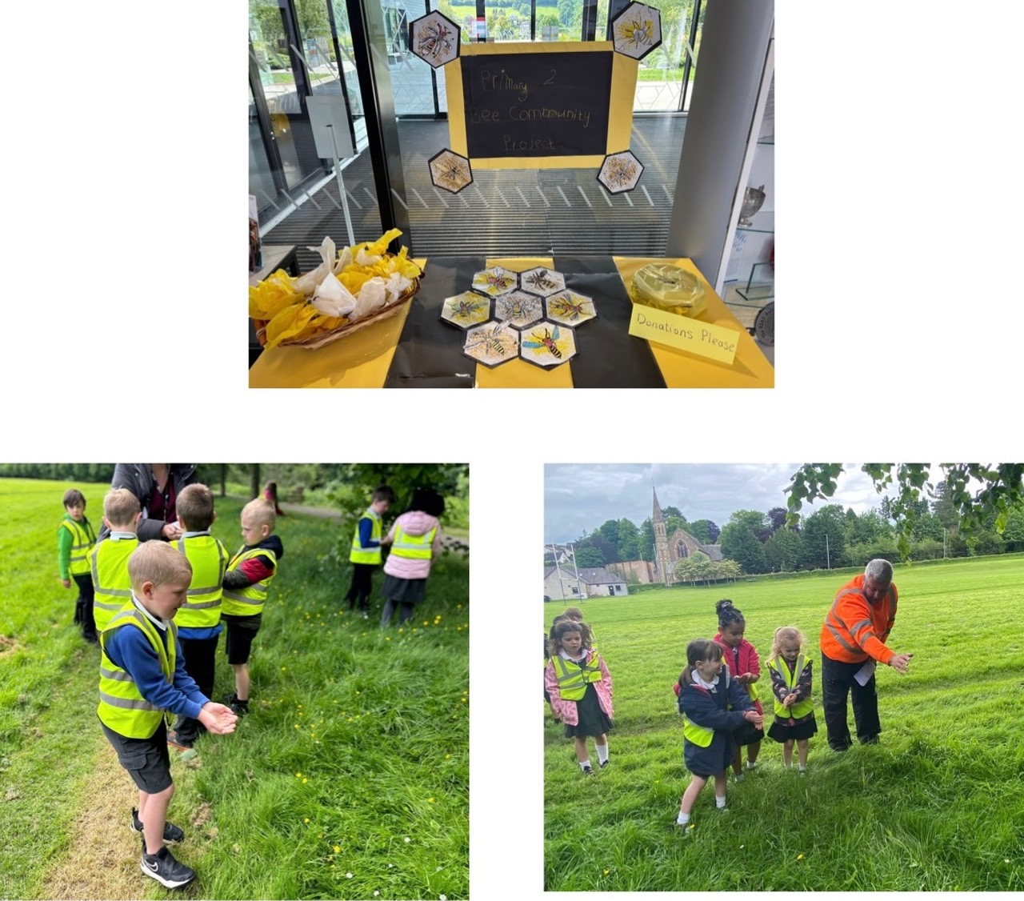
Learning for Sustainability
Primary 2 children have been learning about bees and how to encourage them to visit our community. We have set up a bee community table in the school reception selling wildflower seeds in the hope that people will make a donation and plant the seeds in their garden. The children also planted wildflower seeds in Jedburgh at the Glebe. The proceeds from this project will go towards supporting a local charity.

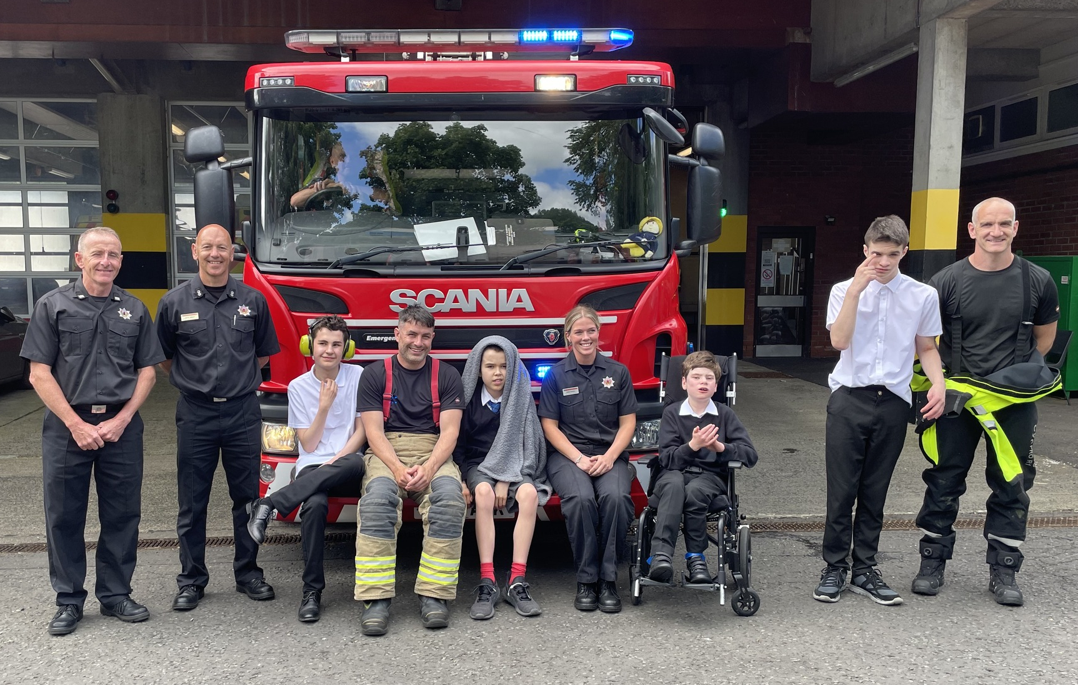
JGC On Tour
Primary 6 and S2 pupils joined learners from schools across the Borders at Springwood Park this week, for the Inspire Learning Festival and here are some of our secondary pupils enjoying a trip to Hawick Fire Station on Monday. They loved meeting the firefighters and learning about the equipment!

JGC Sports

Wednesday 12th June P4 to S6
Secondary events will start at 9.15am at the Spider Park (Howdenburn Drive). These include high jump, wacky races, capture the flag, tug of war and inflatables. Pupil schedules and timings have been shared with year groups and will be uploaded to all PE Showbie groups today.
Pupils are asked to come to school in PE kit (house colours where possible). Parents and carers are welcome to watch from the raised embankment area.
Track events will also take place at the Spider Park from 1.10pm: 100m, 200m, 300m, 600m and 1500m (300m-1500m are also open to P6 and P7). This will then be followed by secondary house relays.

Primary events will start at 10am at the Spider Park. They will rotate through a variety of stations including sprinting, standing long jump, high jump, hurdles, wacky races, shotput, javelin and relay. These events will finish for lunch at 12.10pm. P4 and P5 pupils will return to school for lunch and remain there for the afternoon. P6 and P7 pupils will return to the Spider Park for 1.10pm for capture the flag, tug of war and any track events they would like to enter.

Friday 14th June P1-3
This event will take place on the 2G pitch at JGC, from 9.30am -11am. Pupils will rotate through 7 different stations - sprints, hurdles, egg and spoon, sack race, standing long jump, shot put and javelin. Pupils are asked to come to school in their PE clothes, house colour tops where possible. Parents and carers are welcome to watch from a designated area in the centre of the pitch.

