
Campus Update

4th October 2024

Dear Parent/Carer,

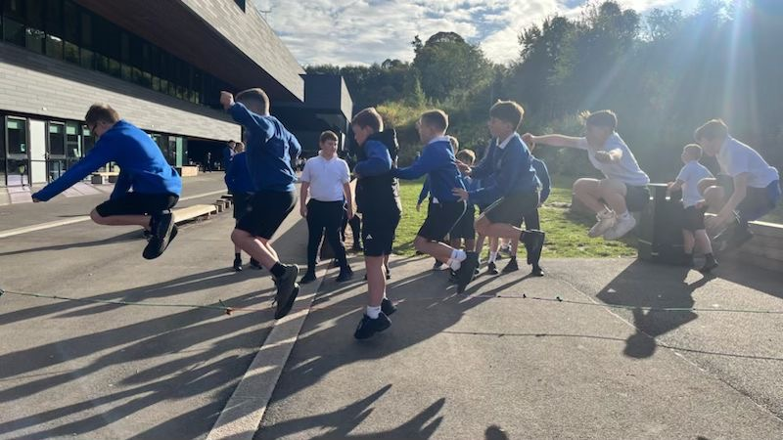
Thank you to everyone who supported our Macmillan Coffee Morning last Friday, enjoying delicious treats, entertainment from our P1s and contributing to over £500 being raised for such a worthy cause.

This week we have been enjoying the autumn sunshine (P5 &P7 pupils picture today), with lots of learning happening outside.
P6 children have been taking part in the Bikeability programme, supported by SBC’s Outdoor Learning team and our very own senior phase Mountain Biking students. Let’s hope the weather remains kind for week 2!

We have a busy week ahead in the run up to the October holiday, with flu vaccinations on Tuesday, our Positive Futures Careers Fair for P6 – S6 on Thursday and our P1-7 Harvest Festival on Friday.
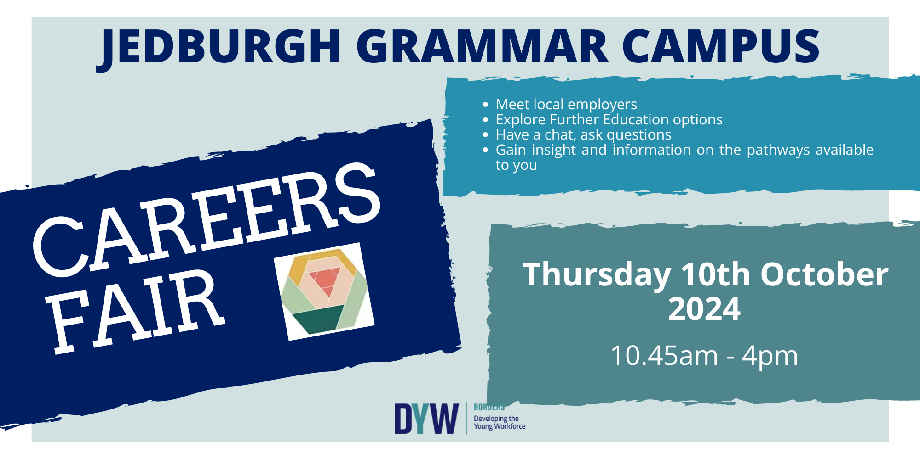

In the meantime, I wish you a lovely weekend.


Susan Oliver
Headteacher
School Photographs
Our photographer will be in school on Wednesday 23rd (Primary) and Thursday 24th October (Nursery & Secondary). All pupils who have permission for photos to be taken will have the opportunity to do so.
As happened last year, there will be a limited number of slots after school for family photos. Anyone wishing to request a slot should email JGC@scotborders.gov.uk with the names and classes of the siblings. Slots will be allocated between 3.45pm – 4.45pm over both days. Please note that a parent must attend with their children.

Wellbeing

Zones of Regulation
In change to our planned professional learning programme for this session, our primary staff have been learning about Zones of Regulation. The programme offers children and staff a common language for communication, problem solving and emotional understanding, with the aim of increasing self-awareness and social and emotional skills and building regulation strategies into day-to day routines.
We were delighted that many of our support staff gave up their own time to join teachers at an after-school training session yesterday and we are planning to offer a session next term for parents who would like to find out more about the programme. Parents of children who attended Ancrum Primary may be familiar with the programme already and aware of the positive feedback it has received from children, families and staff there.

Family Learning - Jed Hearts Here
Reminder that the Jed Hearts Here team are running another community ‘Come and Try’ day at the Fire Station on Sunday 6th October from 11am – 2pm, where all age groups are welcome to learn about CPR and how to use a defibrillator should you ever need it.

Learning Without Limits

P2 Artists
P2 have been creating some beautiful artwork using water colours, to illustrate their water topic. The children have drawn outlines of mountains, hills, lochs, streams and rivers and when the outlines are pulled off, they will then add more detail using pastels. They’re going to look amazing!

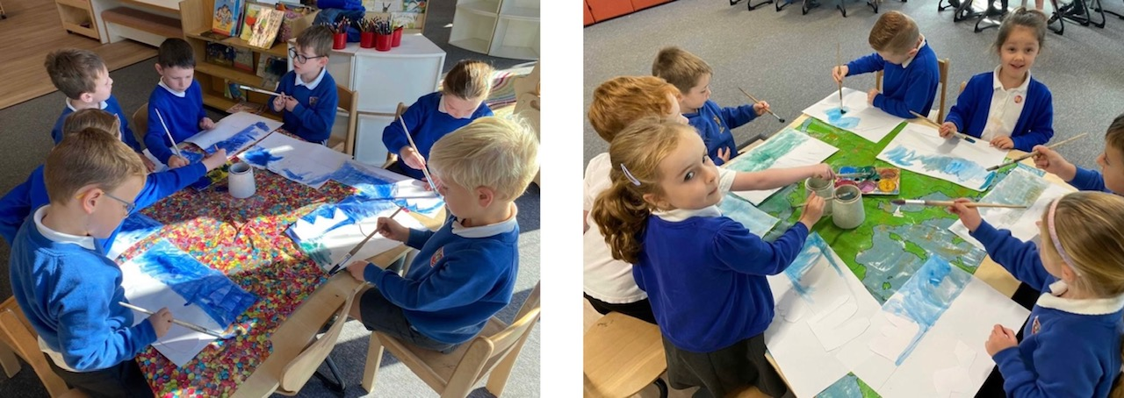

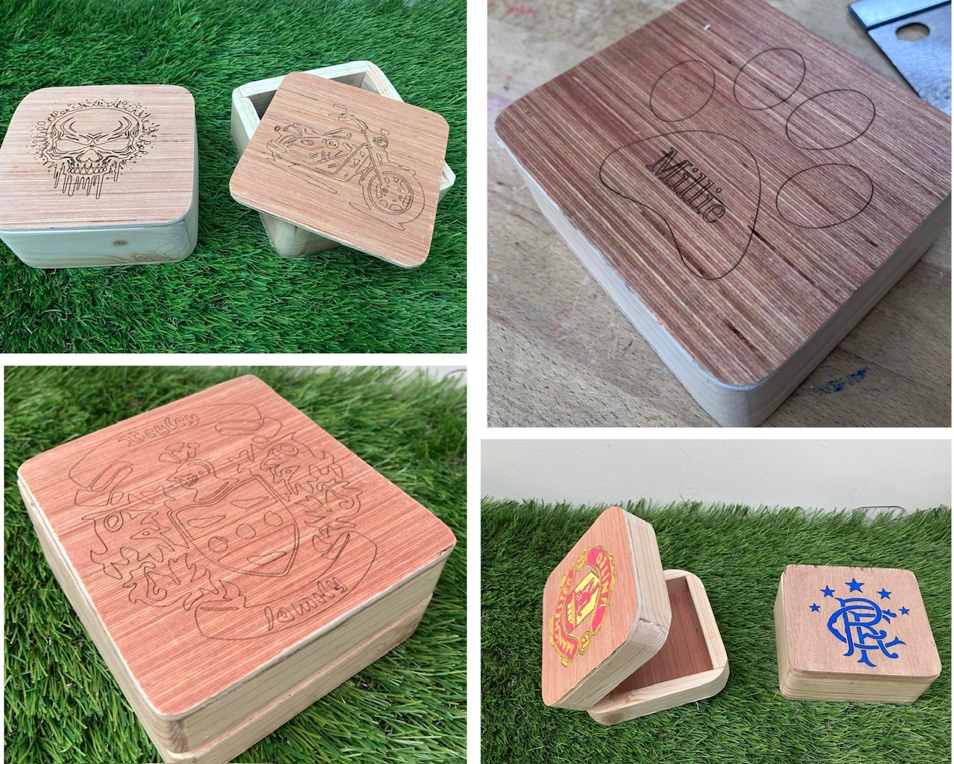

S1 Design Projects
S1 pupils have loved showing us their fantastic creations this week. They have been developing their technical and design skills, producing beautiful trinket boxes.

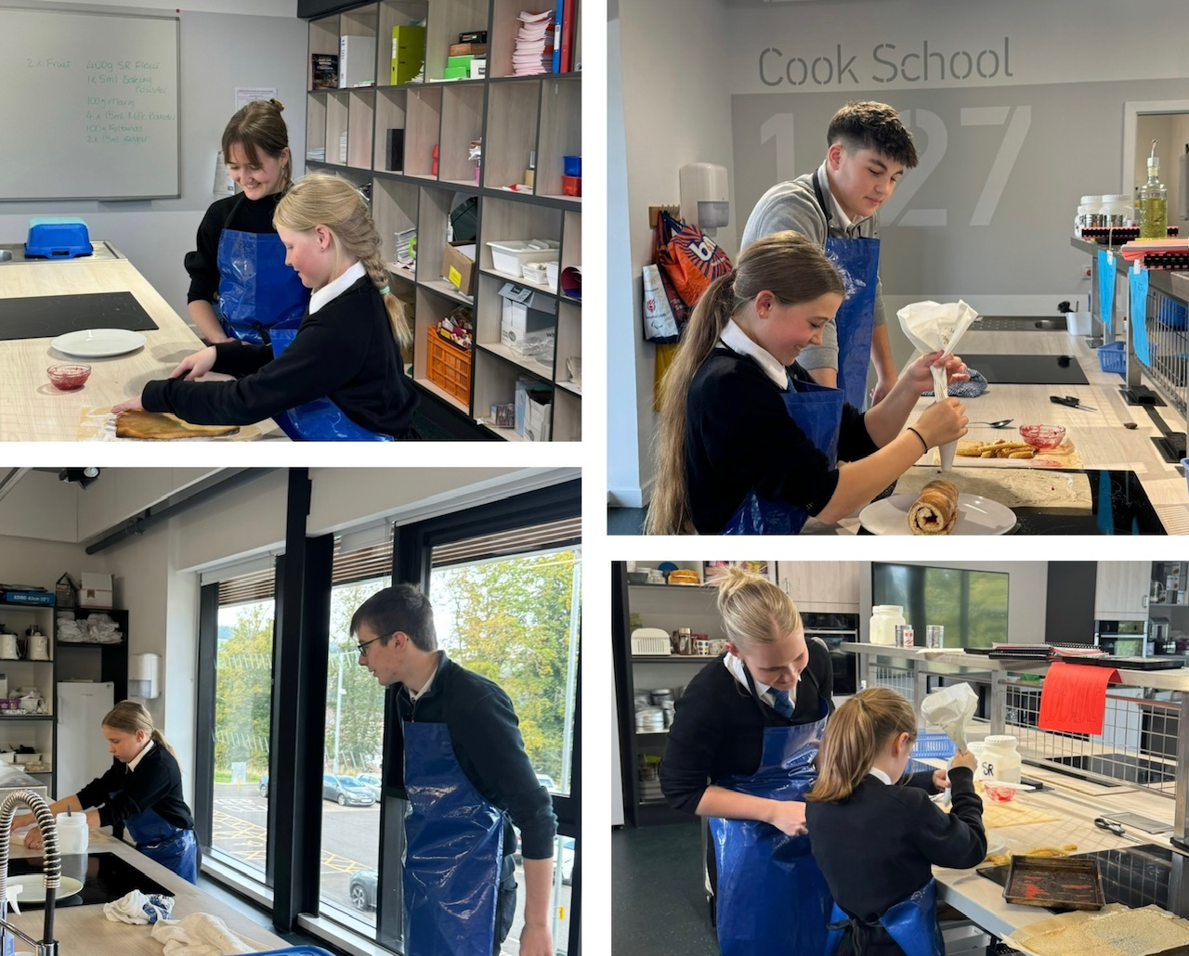
Inter-house Bake Off
What a lovely buzz we had at lunchtime yesterday, during our inter house bake-off competition.
Each house entered a pairing of an S6 and S1 pupil, working together on the technical challenge of baking and decorating a Swiss Roll.

Congratulations to Redeswire on their winning creation and a huge well done to everyone involved! Special thanks to our S6 Head Team and Miss Mackay for organising this event.

Our School Captains are leading the introduction of a new programme of inter-house activities and will be meeting with our P7 Head Team to plan some events for primary children.

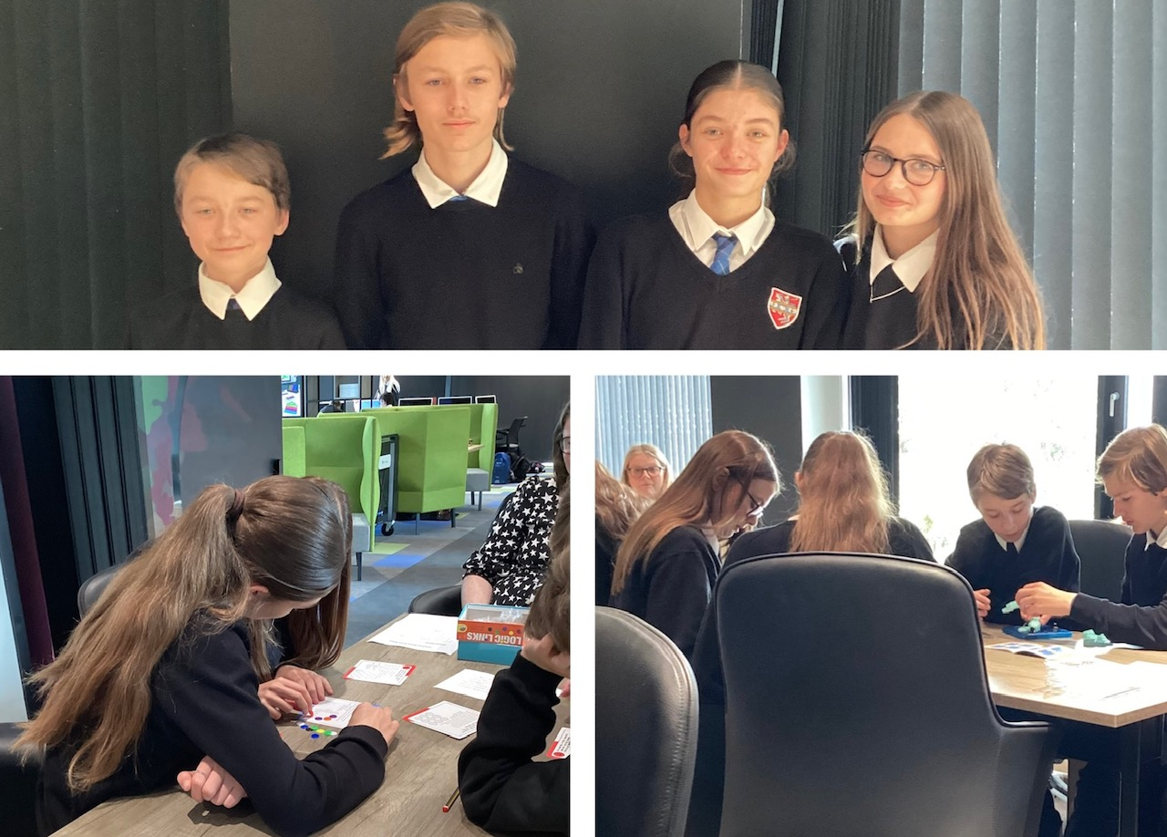
Enterprising Maths
Congratulations to our JGC team of S3s Dawid Koniecki and Travis Rankin and S4s Hannah Craig and Sienna Cooper, who represented JGC at the regional Enterprising Maths competition this week.
Pupils completed a series of maths challenges and puzzles against 6 other SBC secondary schools, finishing in 3rd place. They performed particularly well in the puzzles challenges and Travis was the only person at the event to complete the cube puzzle.

Pupil Voice
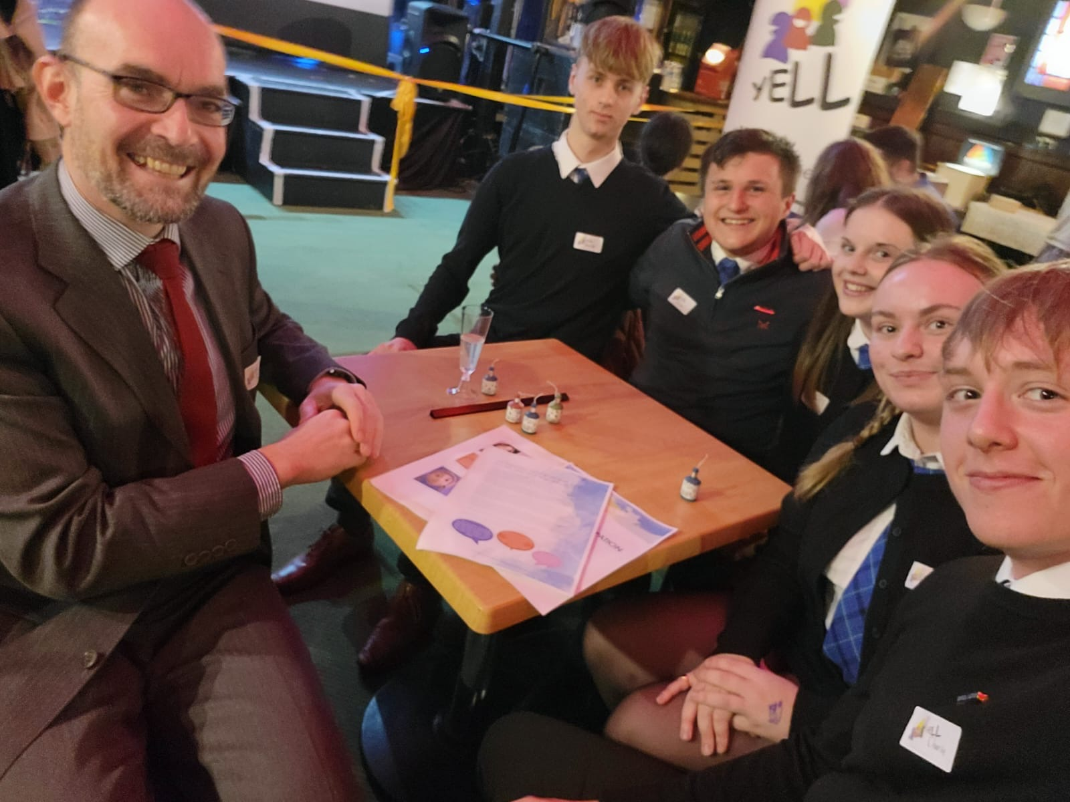
Mr Fagan and pupil representatives were delighted to attend the launch of Scottish Borders Council’s new youth participation and engagement strategy on Monday evening at the MacArts Centre in Galashiels.
(Pictured JGC Senior Head Team and Alex Wieczysty, S5, who represents youth voice on SBC’s Education Executive Committee).

The strategy has been co-produced with young people, including our very own Ella Marshall (S1) and its purpose is to provide a ‘how to’ guide for professionals to facilitate effective and meaningful engagement with 12 – 25 year olds.

We are looking forward to engaging with the strategy, linking to our work towards becoming a Rights Respecting School and article 12 of the UNCRC (Children and young people’s right to be heard).

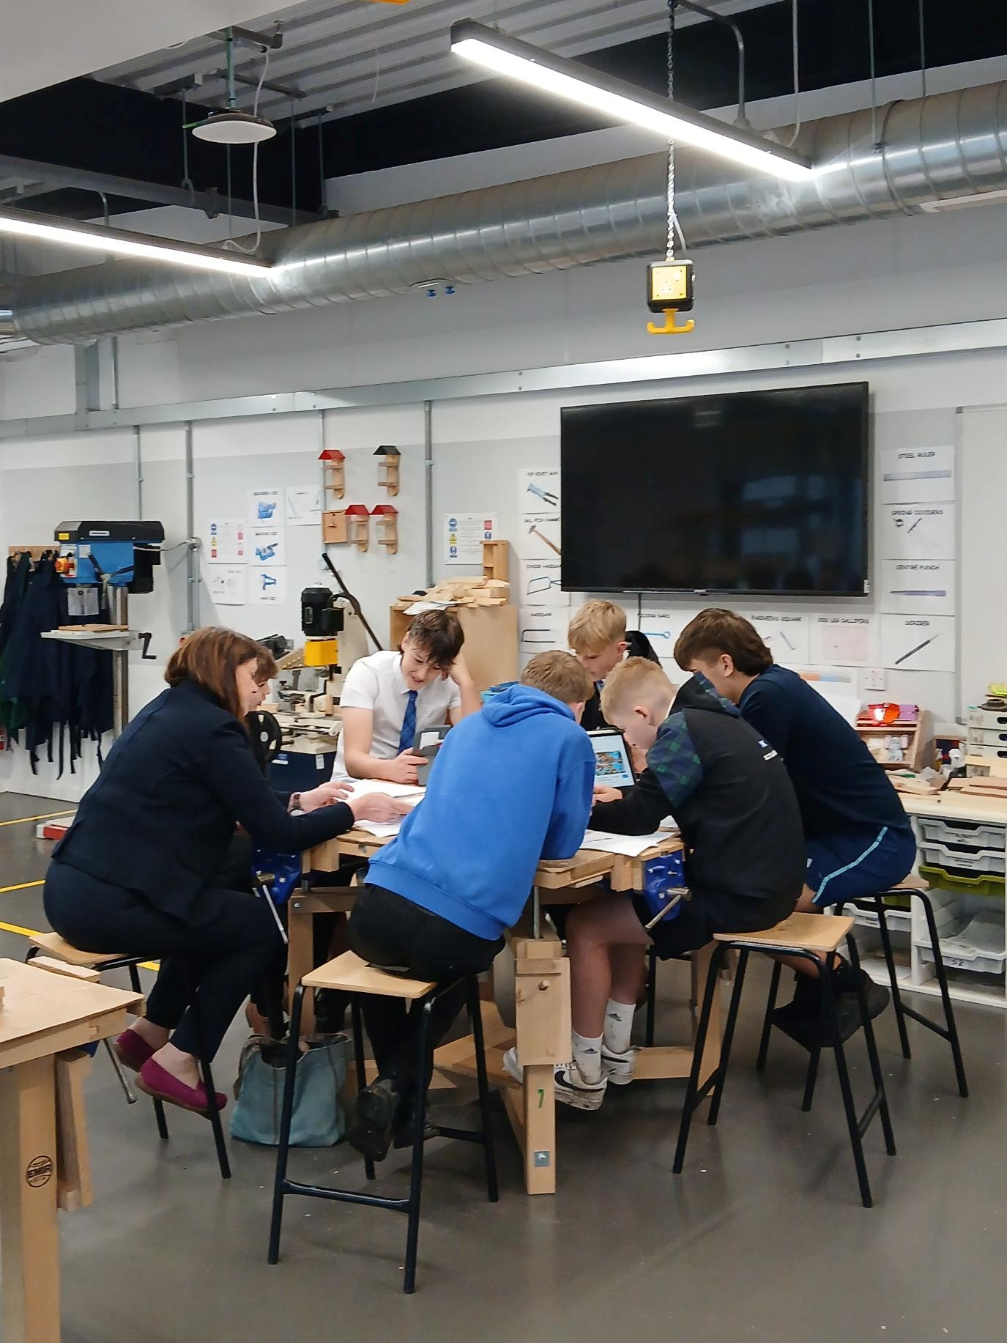
Developing the Young Workforce
This week pupils from our S3 Practical Crafts class took part in a Repurposing workshop to help gain an understanding of the factors influencing the design of buildings, their value in a community and the ways in which sites can be re-utilised. Pupils also enjoyed measuring and identifying the materials used in the design of the campus. Thank you to Debbie and Daniel from SBC Planning Department and Alan from SBHA for facilitating the workshop with DYW and sharing insight into their job roles.
