

Campus Update

21st March 2025

Dear Parent/Carer,

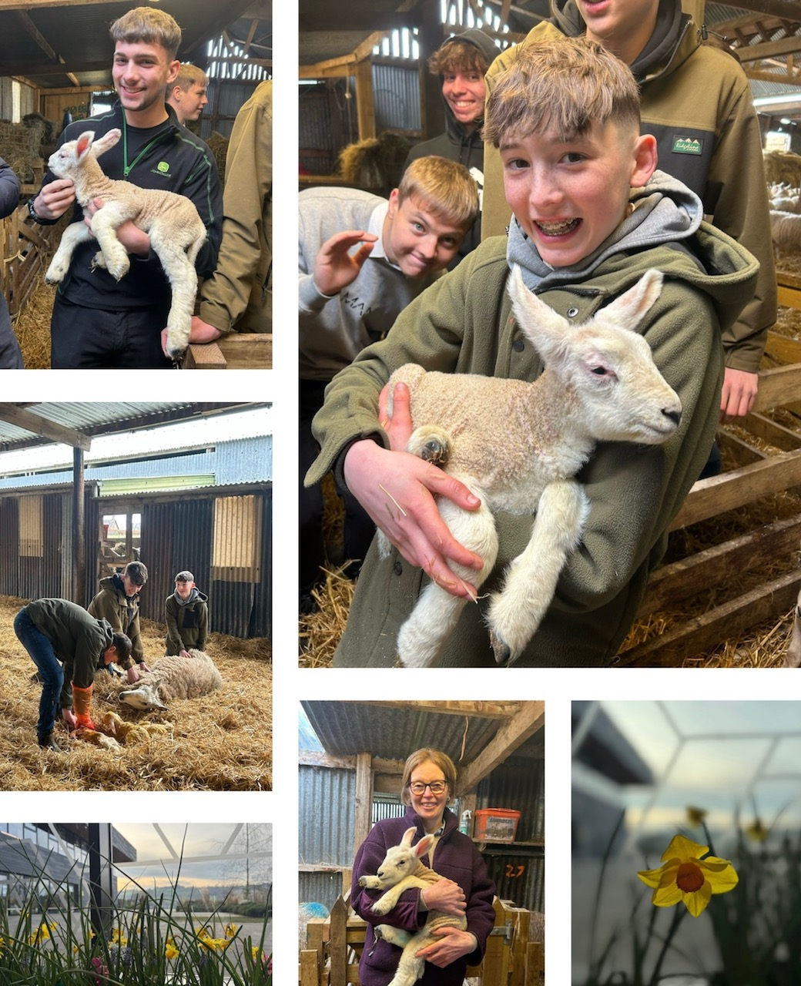
Spring has sprung!

Children and young people across the campus have welcomed the beautiful weather this week and the campus foyer is now smelling lovely thanks to the spring flowers provided by our Eco team.

Our senior agriculture class had a fantastic farm visit this week, witnessing 6 lambs being born. Some of the young people are very experienced in lambing and inspired Miss Mackay and Mrs Johnston to help deliver two lambs.

I hope these photos
make you smile as much as they made me smile!

Please note the information regarding a meeting about the swimming pool and the free community events advertised at the end of this update, which are taking place tomorrow and may be of interest to you and your families.
Our Senior Hockey Team would also be delighted if you would join them at their coffee morning in the Jed Thistle Pavilion at the Glebe tomorrow from 10am – 2pm.



Susan Oliver
Headteacher

Staffing Update
We are delighted to have three new members in our Jedburgh cluster team, who will work with us to create opportunities and offer support to children, young people and families across Jedburgh and Ancrum. Alan Reid has taken up post as our Active Schools Co-ordinator, Mary McIlraild is our new Community Learning and Development Worker and Christie Brown has been allocated as our Education Psychologist.

Learning Without Limits

St Patrick’s Day
P1 were learning about St Patrick on Monday and had lots of fun making shamrock hats.
Don’t they look great!
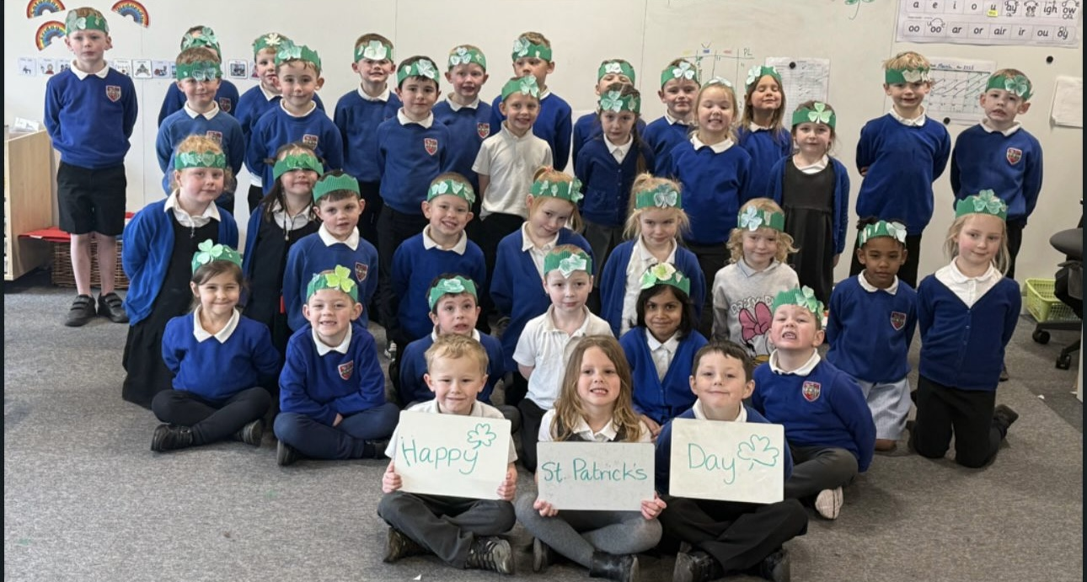

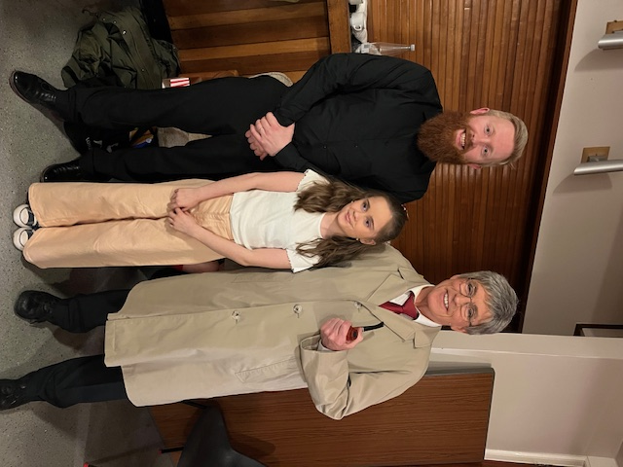

Made in Dagenham
JGC was well represented in the Hawick Amateur Operatic Society Musical Theatre Company production last week. The wonderful Mr Jeffrey played in the band and Inga and Mr Murray gave excellent performances as Sharon O’Grady and Harold Wilson.
Great to see some former pupils. Alexander Edwards, Skye Ritorto and Carys Williams starring too!

Laidlaw Memorial Pool – message from the Royal Burgh of Jedburgh Community Council

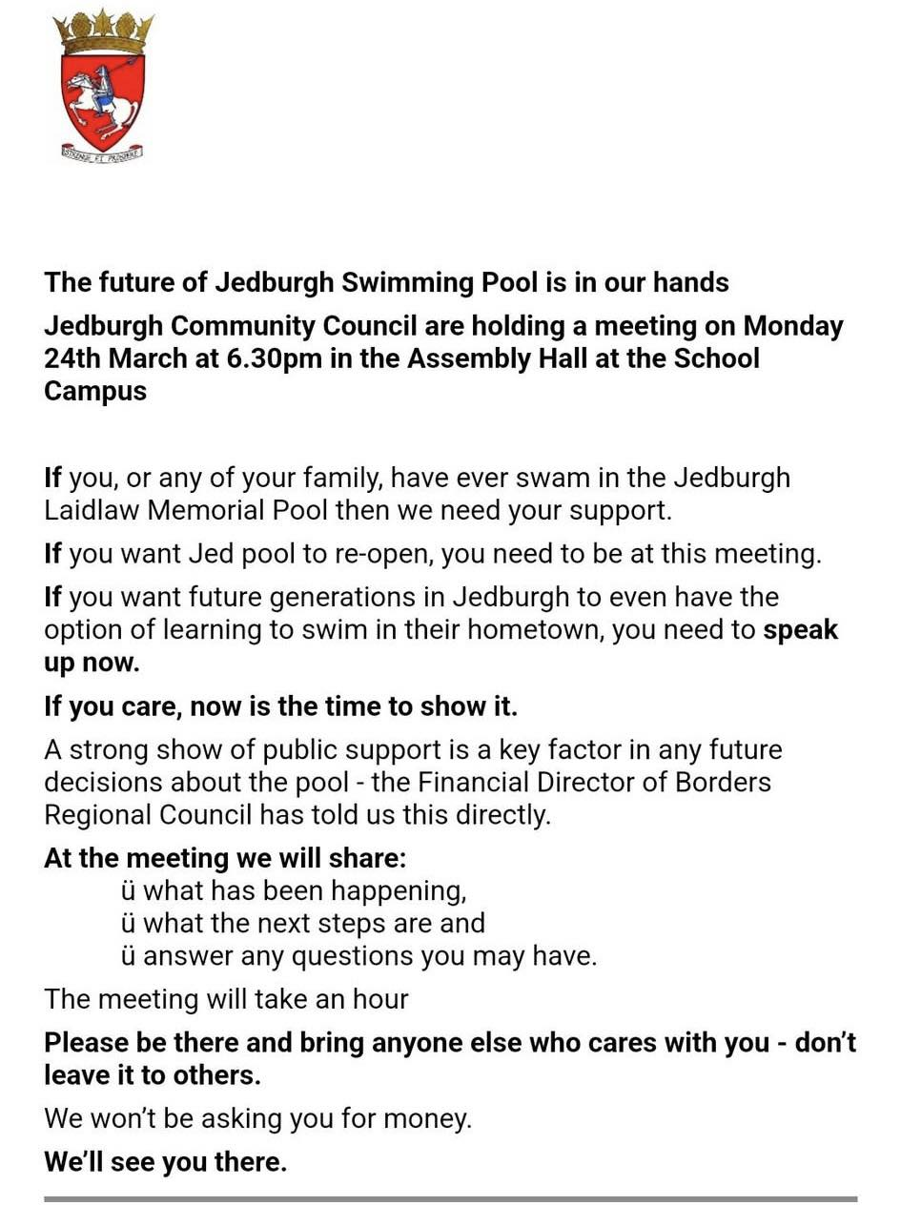
Community Events
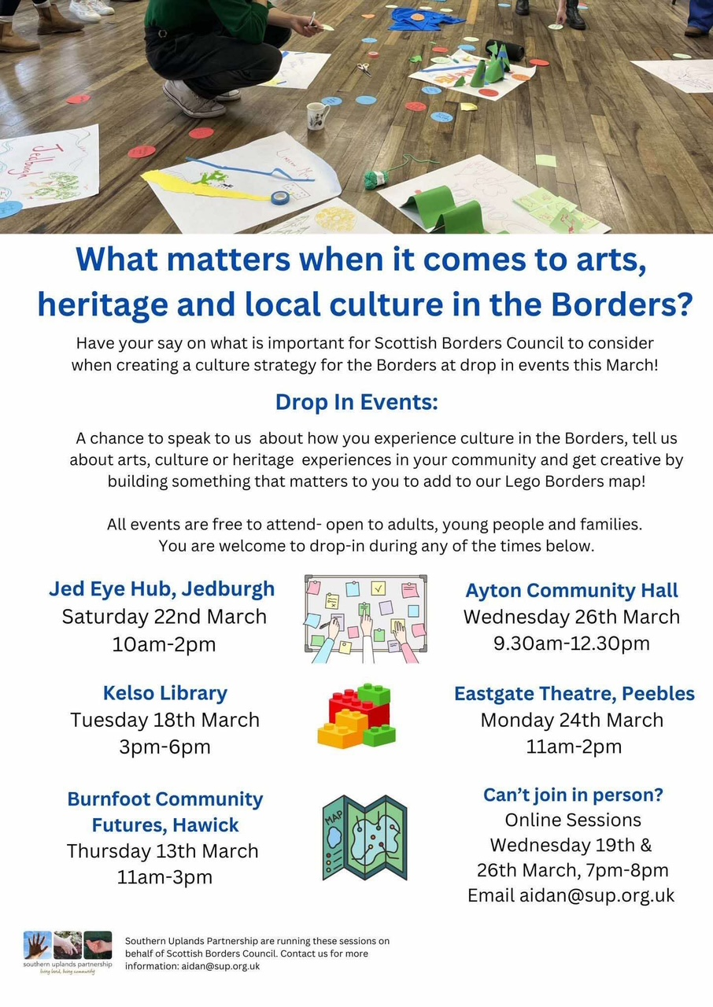
The Southern Uplands Partnership are going to be in Jedburgh on Saturday morning at The Jed Eye finding out what Jed folk want when it comes to art, music, theatre, entertainment, heritage. They would love to hear from everyone, including young people. They will be doing some LEGO play too!

