
Campus Update

14th June 2024

Dear Parent/Carer,

Another jam-packed week at JGC!
Thank you to everyone who joined us at our first ever JGC Summer Concert. We were treated to a range of fabulous performances from very talented young people from P7 to S6. We can’t wait for our first JGC Show: High School Musical JR on 26th & 27th November.

Our 2-year-old ELC children and family members enjoyed a lovely Teddy Bears Picnic yesterday and ELC3/4 and P4-S6 Sports Day took place on Wednesday. We saw some outstanding athletic achievements, alongside a huge amount of fun and laughter. Unfortunately, the weather meant we had to move our P1-3 events inside today, but it didn’t dampen the spirits of the children and they all had a ball. Huge thanks to our staff, senior sports leaders, volunteers and Live Borders partners for their support in making these events possible.

I am delighted to share with you that Mrs Alison Hardie was appointed as our new PT Support for Learning this week and will take over from Mrs Cuthers, who is looking forward to a well-earned early retirement in the summer. We felt very lucky when Mrs Cuthers applied to join our team in 2021, bringing a wealth of experience from her previous roles, and we are grateful for the positive impact she has had on many children, young people and families during her time with us. She leaves with our very best wishes for whatever life holds next.

I am also pleased to be able to share with you that Miss Doyle will be staying with us next session, joining Ms Gulliver in P5, and Mr Tait will be returning to our campus Health & Wellbeing team. Following his performance in the staff relay on sports day there has been a lot of discussion as to which house team he will be joining in August. We’ll see what the sorting hat decides . . .

Best of luck to our young people who are competing in County Sports events next week and we hope our P7s have a fantastic time on their residential at Ford Castle and our new S2s and senior Agriculture students have a great time at the Highland Show.

At the end of this update, you will find a reminder of uniform expectations for JGC. Following consultation with our young people, secondary pupils will now be permitted to wear plain black hoodies or hoodies bearing the JGC badge (black or JGC sports). Thank you to the parent who sent us a link for school uniform discounts! School Uniform Sale Dates 2024 (moneysavingcentral.co.uk)

Wishing you a lovely weekend.


Susan Oliver
Headteacher

Learning Without Limits

Youth Climate Action Fund
Congratulations to our Eco Committee who have been awarded a grant of over £900 after applying for funding to expand our current equipment for our gardening and biodiversity programmes.

SQA Results
Ahead of results day on Tuesday 6th August, SQA have produced a new booklet called 'Your Results'. The booklet contains information on all the support available to learners as they receive their results and consider next steps. It includes: an overview of what to expect when receiving their results; details around certificates; frequently asked questions; how exams are marked; appeals information and more. A hard copy of the booklet will be included along with the certificates and anyone who wants to read it before results day can download the digital version from the SQA website now.

ELC2 Teddy Bears Picnic


Sports Days

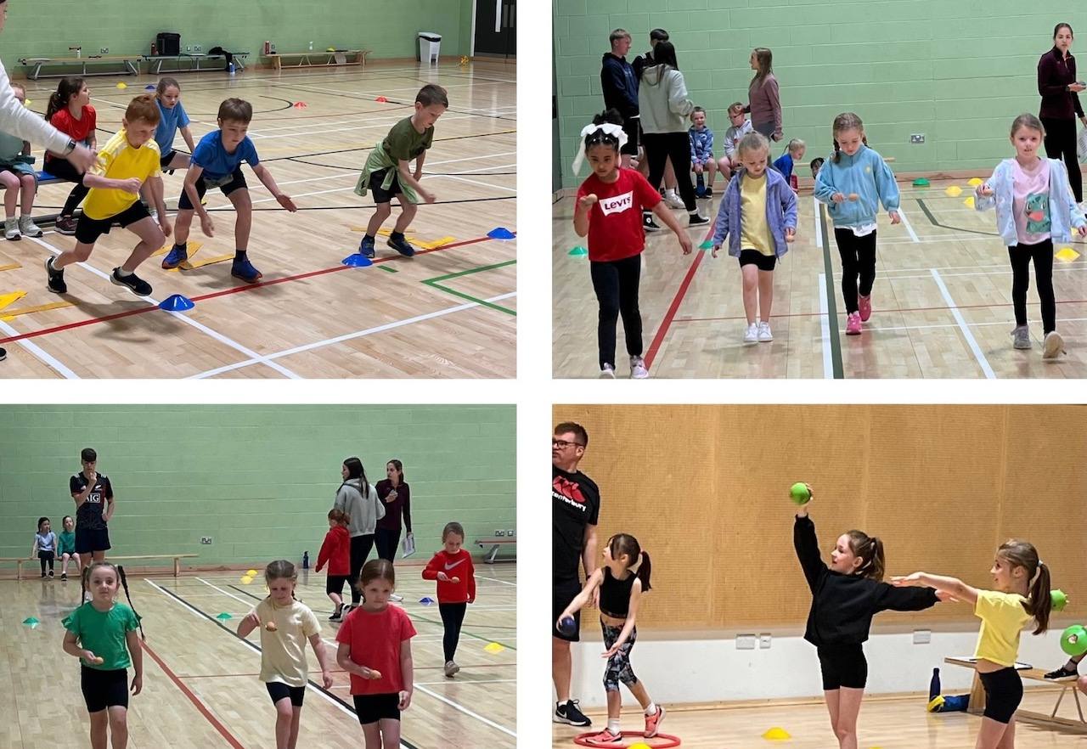

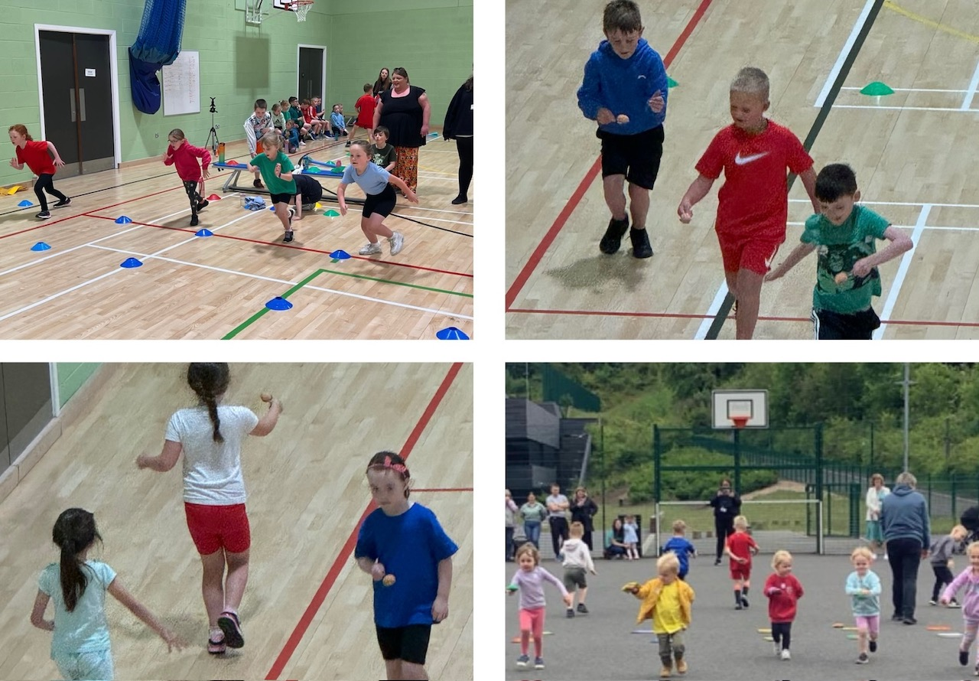
Uniform
Uniform helps us to:
- Foster a sense of belonging and pride in JGC
- Develop a purposeful and focused ethos in the school
- Promote equality among pupils
- Prepare our pupils for the world of work
- Foster the positive image of our school and pupils in the community
- Make it easy for parents, pupils and staff to know what we expect pupils to wear to school

JGC Uniform is as follows:
Primary
- Plain or embroidered royal blue sweatshirt, jumper or cardigan
- Grey or black trousers/skirt/shorts/pinafore (not sportswear)
- White shirt/polo shirt
- Dark footwear, preferably school shoes
- Tie optional
- PE kit: t-shirt (house colour/white), shorts, trainers and jumper or jacket (weather dependent), no football strips.

Secondary
- Plain or embroidered black sweatshirt, jumper, cardigan or hoodie
- JGC embroidered sports hoodie
- Black trousers/skirt/shorts (not sportswear)
- White shirt with school tie
- Dark footwear, preferably school shoes
- Indoor PE: t-shirt (no vests/crop tops, no alcohol/tobacco advertising), shorts/leggings/tracksuit trousers, clean trainers
- Outdoor PE: as above, along with jumper or jacket (weather dependent). Hockey pitch footwear: clean trainers or astro trainers with small dimples. Rugby/football pitch footwear: studded boots only. Athletics track footwear: clean trainers or spikes

Nursery
There is no uniform for nursery but, following parental requests, a red embroidered sweatshirt can be purchased.

Ties can be purchased for £7.00 (through Parentpay) and collected from reception.
If you wish to purchase items embroidered with the school badge you can do so from Middlemiss Embroidery: www.middlemissembroidery.co.uk

Financial Assistance for School Meals & Uniform
We are aware that not all families who are eligible for assistance claim this support. The Scottish Government provides additional funding to schools based on pupils who are entitled to free school meals, therefore if all who are entitled apply, at school level we can offer more support. Families in receipt of free school meals/clothing grants are also eligible for additional support with activities during term-time and school holidays. Please visit this web address to find out more about eligibility. Free school meals and help with schoolwear | Scottish Borders Council (scotborders.gov.uk)
If you would like assistance in submitting an application, please contact JGC reception.


