
Campus Update

28th February 2025

Dear Parent/Carer,

A highlight of this week was hearing that our JGC Scottish Poetry Champion, Charlie Whitecross P7, has also won the Primary Scottish Burns Competition for the Scottish Borders. The judges from the Borders Association of Burns Clubs were really impressed with the quality of his entry. I’m sure all of you who have seen Charlie’s performance will agree it was very well-deserved.

Next Thursday will be an exciting day for us with the combination of World Book Day and the Jethart Hand Ba’!

As shared previously, anyone wishing their child(ren) to participate or spectate in the Hand Ba’ must email JGC@scotborders.gov.uk or send in a signed note before Wednesday 5th March, including names, year group and whether they will be collected or they have permission to leave school unsupervised at 11.45am. Pupils will not be permitted to leave school unless parental permission has been received.
Pupils leaving school at 11.45am have permission to come to school dressed in casual clothing, as appropriate for Ba’ Day. School transport will run as normal at both the start and end of the school day.

As a school, we will be celebrating World Book Day by engaging in reading and book themed activities across the campus. Once again, primary children are welcome to bring their favourite book and come to school wearing their PJs. As it is also Ba' Day if your child would like to wear PJs and change later this is fine but, equally, if they would rather wear uniform or Hand Ba' clothes only, that’s fine too!

Please keep an eye on primary class Showbie pages for further information regarding World Book Day activities.

Wishing you a lovely weekend.



Susan Oliver
Headteacher

Wellbeing

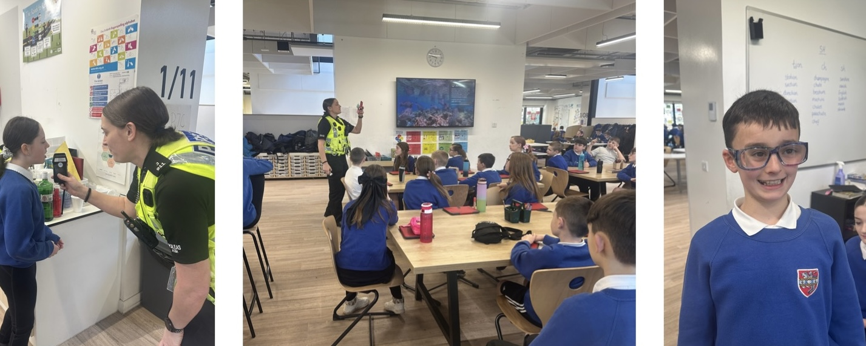
PC Tait-Logan has been working with P7 again this week on their Health & Wellbeing topic. They have been learning about the impact alcohol has on their body and the risk & dangers.
Message from our JRSOs
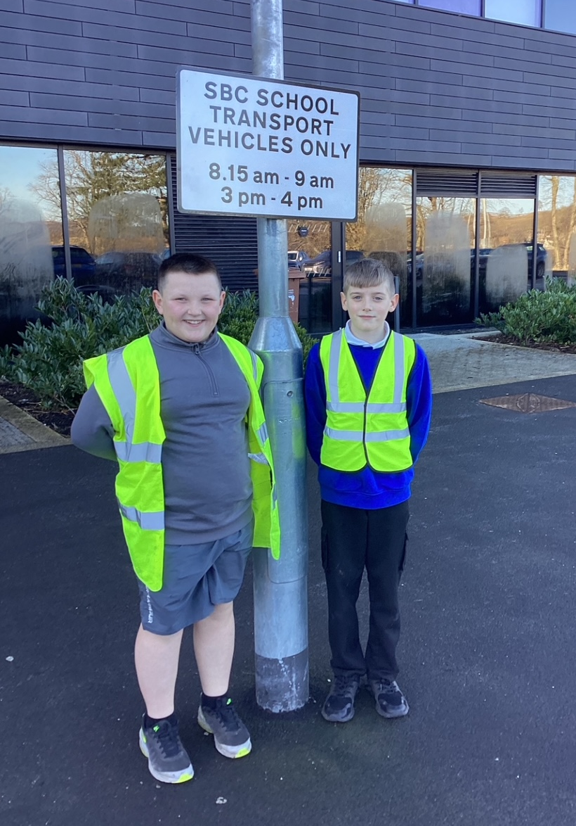
One of our jobs as Junior Road Safety Officers at Jedburgh Grammar Campus is to support our JGC value of wellbeing and highlight safer routes to and from school.
A key focus this term is making access to and from the Campus as safe as possible for everyone. We have been watching traffic in the morning and at the end of the day and have seen dangers in the car park where cars are not parking in the proper spaces. Cars are double parking, parking on the pavement, parking in the drop off zone (despite the sign showing times that are allowed), parking in the bus bays and parking in the disabled bays without a blue badge. All these actions put us at risk when we are coming to and from school each day. The last time we had a fire drill there were 3 cars parked in our evacuation zone (bus bays). This meant we couldn’t line up in our classes safely.

Previous JRSOs got new signs installed in the car park and got more cones to stop bad parking on the road. They worked with PC Tait-Logan and Karen McGrath (SBC Safer Routes to School Officer) and came up with a system of photographing dangerous parking and issuing parking tickets. A ticket is put on the windscreen of the car and we ask that the driver returns the ticket to the campus reception. We pass on the photograph and registration to PC Tait-Logan of any drivers who don’t return our parking tickets to reception and she then speaks to the driver.
We will be out in the car park in our Junior Road Safety Officer hi-vis jackets each morning so you all know who we are. Please give us a wave if you see us. We hope that this will make people think about their parking and stop any of us getting injured.
Tyler and George, P7

In addition to the concerns highlighted by George and Tyler, we have also received concerns from blue badge holders regarding misuse of disabled bays. Guidance on using blue badges (Using your Blue Badge - mygov.scot) makes it clear that blue badges should not be used to park in a restricted area if the badge holder is not leaving the car. We would be grateful if parents/carers would share this information with anyone who has responsibility for picking up or dropping off their children to help us avoid disabled bays being blocked unnecessarily for lengthy periods.

Learning Without Limits

Course Choices for 2025-26 (further details sent directly to parents)
S2 Parents Information Evening: Tue 4th March 7pm
This evening will focus on the personalisation and choice process for S2.

S3 Parents Evening: Wed 5th March 4.30 – 7.10pm

Senior Phase Information Evening (parents/carers of S3/4/5): Wed 5th March 7.20pm
This evening will cover the options process for students in S3 to S5. Additionally, there will be presentations from SDS, LEAPS, and SAAS, providing information about the supports available to help young people transition to positive destinations after school. These presentations will be relevant for parents/carers of young people in S3 to S6.

S4-6 reports will be out within the next week.
P2 on tour
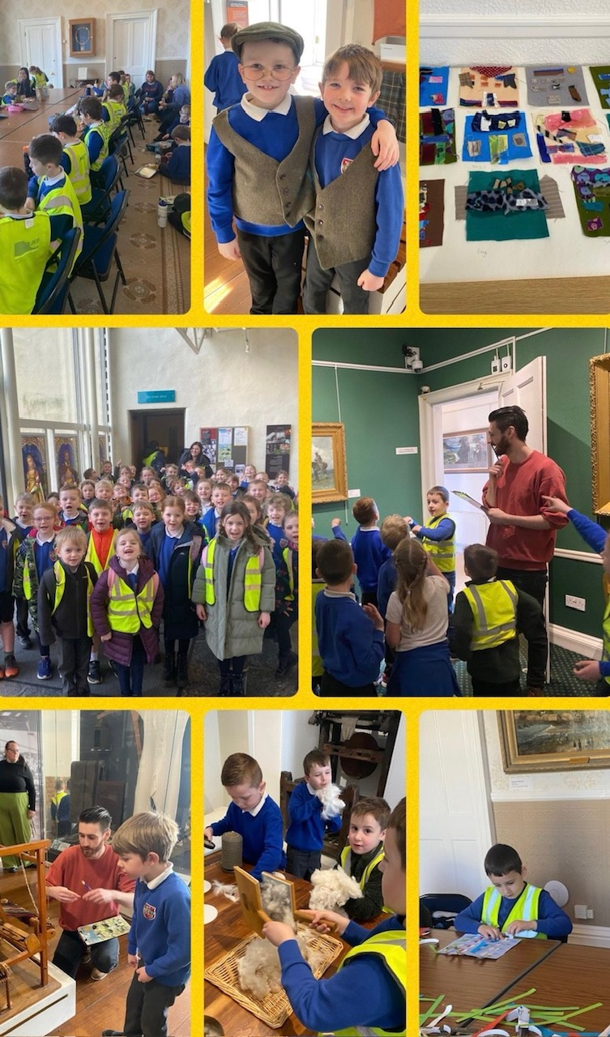
P2 visited the Borders Textile Towerhouse museum in Hawick yesterday. The children tried weaving and used different fabrics to make a scene of the Textile Towerhouse. They also had a tour of the museum where they explored different materials. Many thanks to the parent helpers who supported this visit.

Developing the Young Workforce
Reminder that pupils and parents are invited to attend DYW Borders Scottish Borders Apprenticeship Showcase event tomorrow, Saturday 1st March 2025, at the Tait Hall, Kelso. This offers a brilliant opportunity to engage with universities/ local and national employers to find out about their current and future apprenticeship programmes.

This week S3 Business & Admin pupils had an online presentation from Janice Miller, Scotland’s Business Development Manager from YPO (Yorkshire Purchasing Organisation). Janice shared information on the supply chain process for the jotters that are used in our schools as well as insight into her own career path. Each pupil also received a jotter and pen from YPO.

SBC Parent/Carer Survey
This survey is remaining open for another week. If you have not yet had the opportunity to complete it you can do so via the links below:

Parents/carers of children in ELC (nursery): ELC Survey (Parents/Carers)

Parents/carers of children in primary: Primary Survey (Parents/Carers)

Parents/carers of young people in secondary: Secondary Survey (Parents/Carers)



Cheviot Youth Club
It was great to see numbers increasing at the youth club on Wednesday. Reminder that this is open to all S1-4 pupils every Wednesday after school.



