
Campus Update

28th March 2025

Dear Parent/Carer,

Another busy week here at JGC!
We had a very positive Primary Pupil Council meeting on Monday, where the children were delighted to hear that the Parent Partnership group have agreed to fund buddy benches for the playground. The group will now consider designs and further develop their idea as to how a couple of the benches could be linked to the Zones of Regulation. Zones of Regulation are being used across the campus to help children and young people (& staff!) identify and share how they are feeling and what could help them.
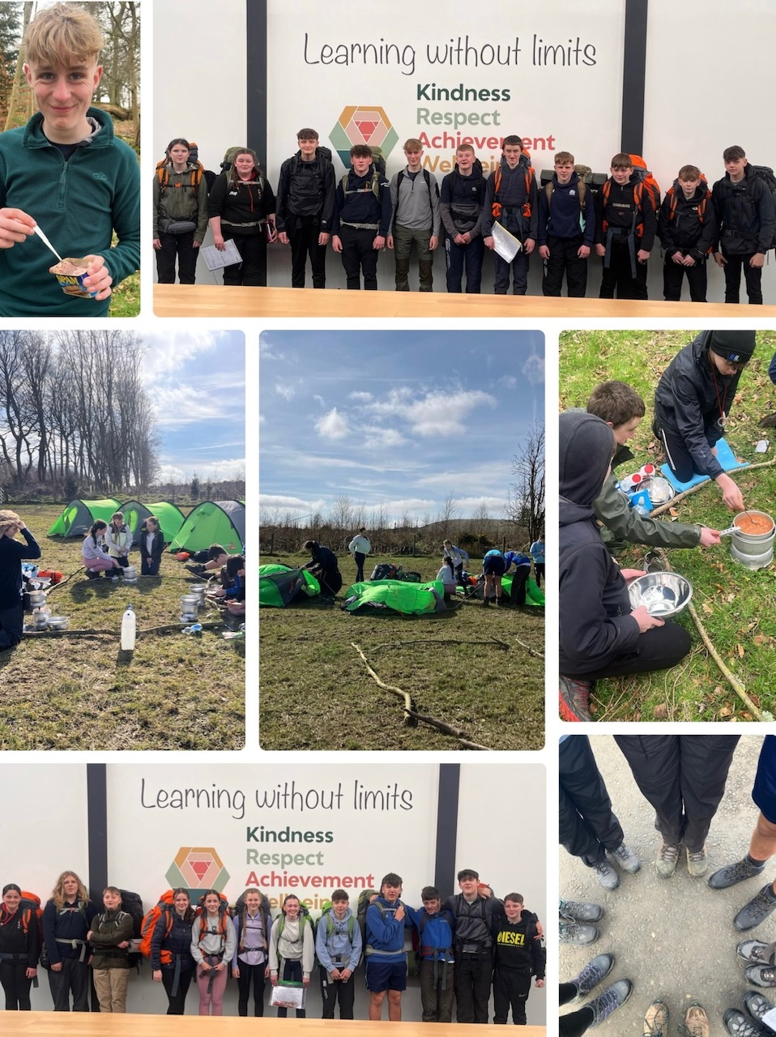
S3 took part in an exciting Youth Philanthropy Initiative final (more details to follow next week) and our Bronze Duke of Edinburgh cohort completed their practice expedition.

Lots of examples of campus values in evidence from young people participating in both programmes.

Here’s a flavour of the D of E experience!

Wishing you a lovely weekend.



Susan Oliver
Headteacher

Wellbeing
It has been drawn to our attention by school bus companies that some parents/carers are removing cones from the entrance to the bus bays and parking there for pick up. This is causing congestion and resulting in children and adults walking behind buses.
Parents have also complained about other parents parking at the side of the drive up to school, making sure their own children are safely dropped off but putting other children who walk to school at risk.
Our Junior Road Safety Officers are doing a great job but are shocked and really disheartened when they see adults ignoring, moving or driving over the top of cones! Please only park in designated areas and help us to keep everyone safe.

Learning Without Limits

New permission system for local area visits
We are looking forward to once again taking the children in P1-S3 to the church for our Spring/Easter celebration. This will take place on Friday 4th April.
Please make sure you have ticked permissions in the ParentPay app allowing your child(ren) to go out in the local community. If this is not ticked children/young people will be unable to join their peers in enjoying local trips in Jedburgh.

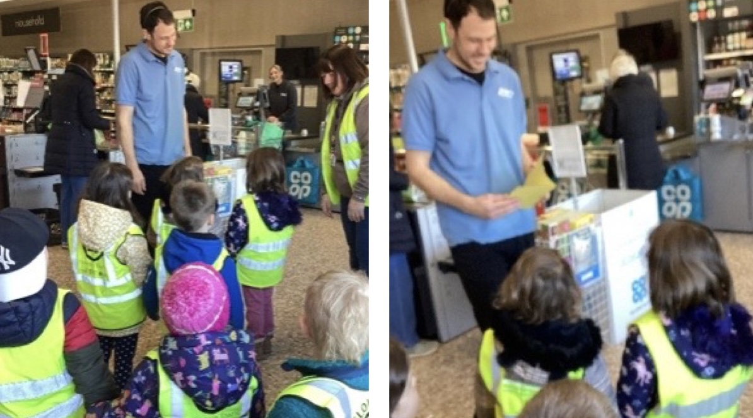
ELC on tour!
Some of our nursery children enjoyed their walk down to the town to deliver the thank you card they made for the Co-op for their recent kind donation. We are looking forward to purchasing some new resources for the children to enjoy.

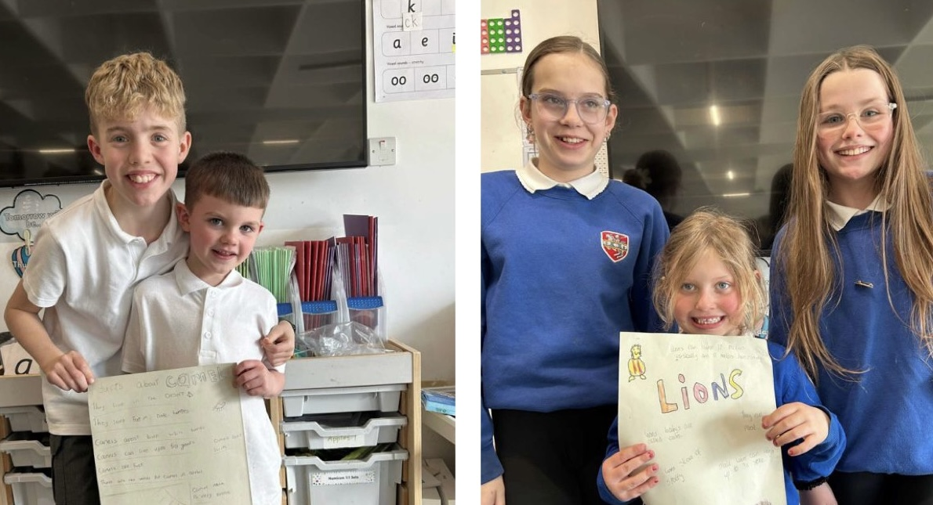

Buddy Time
P1 had great fun working with their buddies and producing posters to share their learning.

Developing the Young Workforce
Last week was Global Money week, and we had some great workshops in school focussing on helping our young people become financially aware. First up, HMRC visited some of our S2 and S3 classes to deliver a ‘Tax Facts’ workshop, sharing insight into the differences between being employed and self-employed. Then S4 took part in MyBnk workshops, where they gained an understanding of payslips, pensions and budgeting as they prepare for the world of work.
We’re very grateful to DYW Borders, HMRC and MyBnk for providing these informative and engaging sessions.
Parent/Carer Voice 2024-25 – Skills Development Scotland
We are very fortunate to have such a fabulous careers adviser in Kim Ferguson. If you and/or your child have engaged with Kim this session SDS would be very grateful if you would complete their survey.

Dear Parents and Carers
Have you engaged with your secondary school’s Skills Development Scotland (SDS) Careers Adviser in academic year 2024/25? If yes, we would like to find out about your awareness of and use of our services and how you talk to your young person about careers through the completion of a 10-minute survey.
Parent Carer Voice Survey 2025
Your feedback will help us to understand your needs as parents and carers, and how we can improve our services.
The survey will be open until the 31st May 2025. Thank you.


Family Learning Opportunity
Back by popular demand! Ms Lambard and Graeme Wilson (Ecologist & Wildlife Educator) have organised another bat walk, departing JGC atrium at 7pm on Wednesday 2nd April. Entry by donation, which will support Graeme's educational work.


Primary children must be accompanied by an adult

